Reporting Landings from IPHC Stock Assessment Surveys

How to Report Halibut from a IPHC Stock Assessment Survey
Vessel Number:
If you are reporting halibut collected during an IPHC stock assessment survey and the vessel is Canadian and therefore does not have a valid ADFG vessel number, then please use the value: 99997 as the ADFG vessel number.
Management Program and IFQ Permits:
- Choose the management program "TEST" and leave the all the fields in the IFQ Permit Worksheet blank. In other words, please leave the NMFS ID, IFQ Permit, Species, Area/Fishery, and Lbs. to max-out fields blank.
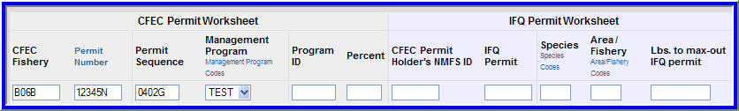
- After you add your itemized catch to your landing report, please submit your initial and final landing report.
- You will not be prompted to generate or submit an IFQ report for this catch since you did not enter NMFS IDs, IFQ permits, and Species on the IFQ Permit Worksheet.
- After you final submit your report, you will receive a WARNING message that says:
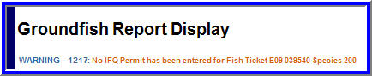
- You can ignore this warning by clicking on the Save and Ignore Warnings button.
- IFQ permits and reports are not intended to be submitted when reporting halibut collected on IPHC stock assessment surveys.
  - Halibut collected during IPHC stock assessment surveys is not intended to be deducted from IFQ permits.

