IFQ Weight(s) for halibut and sablefish

IFQ Weight Calculator
An online IFQ Weight calculator for halibut and sablefish is available here:
https://elandings.alaska.gov/elandings/IfqCalculation
How to use the IFQ weight calculator:
Trying to figure out the complexities of IFQ weights and conditions using the Max-Out feature or the Ice and Slime deduction can be time consuming and frustrating. eLandings now offers the IFQ Weight Calculator link on the Vessel, Permit, Location Information page to the right of the IFQ Permit Worksheet box.
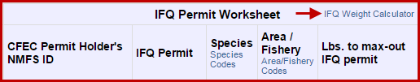
We also added the link to the top of the Add/Edit Itemized Catch page so users can access the IFQ Calculator tool when it’s most needed.
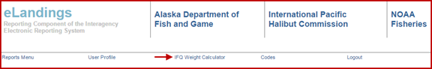
The following is an example of how to use the calculator:

A vessel is landing 3,000 lbs of gutted (04 condition) halibut with I/S and there are two permit holders splitting the catch 50/50. They want to know the IFQ weights (05 condition) that will be debited from their permits.
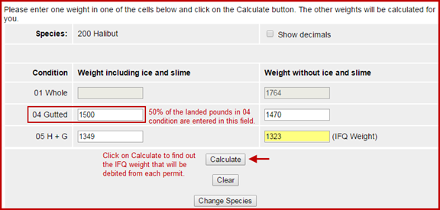
Sablefish can be equally confusing as the pounds debited from the IFQ permit are whole weights! For example, a fishing vessel with two permit holders is landing 2,500 lbs of sablefish (08 condition) with I/S. One permit holder only has 1,200 lbs left on his permit and will use the fish ticket to allocate pounds to permits.
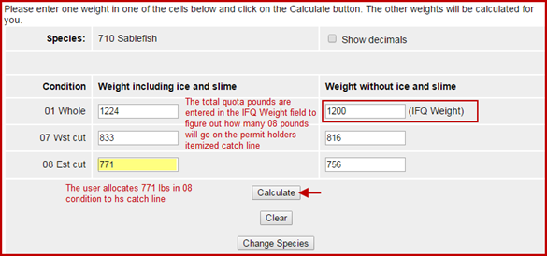

Definitions of weights listed on IFQ Reports

Halibut
When determining which condition code to enter for halibut on a landing report, it should always be the condition code that matches how the fish were at the initial point of landing. This is the condition that they were weighed. The condition can be either:
- 04 - gutted
- 05 - headed and gutted
The Sold Weight for halibut is the weight of the fish when it is landed in either 04 or 05 condition, including the ice/slime. This is sometimes called the scale weight.
The IFQ weight for halibut is the number of pounds that will debited from the permit in 05 (headed & gutted) condition after the ice and slime deduction which is very important to remember when you want to use the max-out pounds feature in eLandings.
- When using the max-out pounds feature, you must indicate the IFQ pounds that you want to come off the permit (keep in mind this should be the 05 weight after the the ice/slime deduction).

Sablefish
Like halibut, the Sold Weight for Sablefish is the weight of the fish when it is landed, including the ice/slime. This is sometimes called the scale weight.
The IFQ weight for Sablefish is always debited in the round weight.
- If you use the max-out pounds feature for sablefish, keep in mind that you need to indicate the IFQ pounds (round weight) that you want to come off the permit.

IFQ Report Examples

Example 1: Halibut landed as 04 (gutted) with ice & slime
In the example below, a total of 10,954 lbs of halibut was landed in 04 (gutted) condition with ice/slime and the pounds will be split among 4 IFQ permits. The Sold Weight can also be thought of as the Scale Weight - this column displays the weight of the fish in 04 condition with the ice/slime. This is the amount of the fish in condition when it came off the boat and was weighed on the scale.

- To obtain the weight of halibut in 04 condition after the ice/slime deduction for the first permit line (980011), you would multiply the Sold Weight X 2% (.02) and subtract that result from the Sold Weight
  - 884 X .02 = 17.68
  - 884 - 17.68 = 866.32
- To obtain the Total IFQ Weight that will be debited from the permit, you would first subtract the ice & slime deduction from the Sold Weight, then multiply by by the 04 conversion rate of .90:
  - Take off the ice/slime deduction: 884-17.68 = 866.32
  - Multiply by the 04 conversion factor: 866.32 X .90 = 779.688
Note: conversion factors can be found in Table 3 to Part 679 - Product Recovery Rates

So Total IFQ Weight shows the pounds that will be debited from each IFQ permit and have accounted for the 2% ice/slime deduction and been converted to 05 condition.
- 780 lbs will be debited from IFQ permit 980011
- 2,905 lbs will be debited from IFQ permit 980013
- 2,075 lbs will be debited from IFQ permit 980001
- 3,901 lbs will be debited from IFQ permit 980007

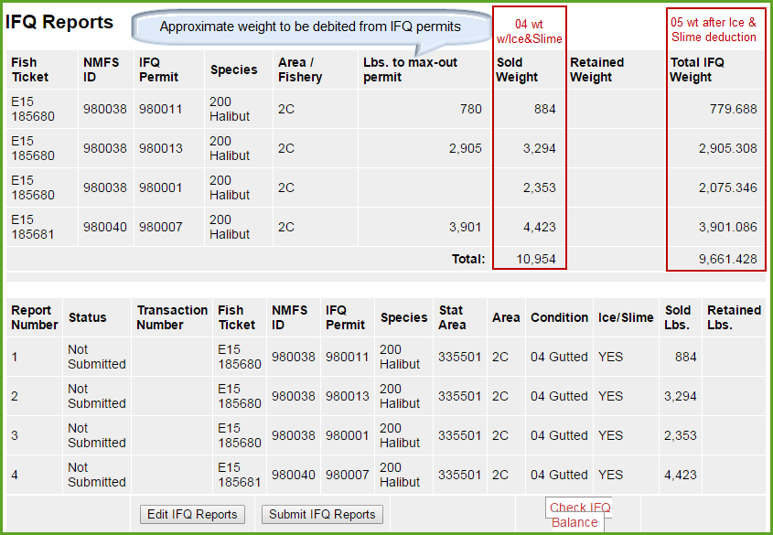

Example 2: Halibut landed as 05 (headed and gutted) with ice & slime
In the example below, 6,542 lbs of halibut were landed in 05 (headed and gutted) condition with ice/slime. The Sold Weight column displays the weight of the fish in 05 condition as it was weighed when it was unloaded off the boat, before the ice/slime deduction.
To obtain the weight of the halibut after the ice/slime deduction, you would multiply the Sold Weight X 2% (.02) and subtract that from the Sold Weight total:
- 6,542 X .02 = 130.84
- 6,542 - 130.84 = 6,411.16
The Total IFQ Weight that will be debited from the permit is 6,411 lbs. In this example, there is no need to convert pounds from one condition to another in this example because the fish was landed in 05 condition. So the only math that needs to be done to get from the Sold Weight to the IFQ Weight is the 2% ice/slime deduction.

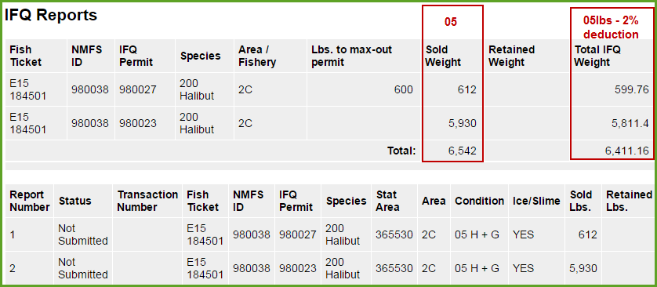

Sablefish
The IFQ weight for Sablefish is always the round sablefish weight. So if you use the max-out permit feature for sablfish you should always indicate the IFQ pounds (round weight) that you want to come off the permit.

Definitions of weights listed on the Fish Ticket
In the example below you can see that there are two different columns that refer to Landed Lbs.

Landed Lbs indicates the weight and condition code of the fish at the point of offload either to a tender, mothership, or shoreside processing plant.
- Halibut must be landed in either 04 or 05 condition
  - Halibut IFQ pounds are debited in 05 condition
- Sablefish or black cod can be landed in multiple conditions but the most common is 08
  - Sablefish IFQ pounds are debited in whole weight units
Landed Lbs with ice/slime deduction
- This column deducts the ice/slime weight (2%) from the landed pounds as documented in the itemized catch section of the report.
