Manual Fish Ticket Number Entry
When you run out of Landing Report IDs and Fish Ticket Numbers, but are still at sea and accepting deliveries, you can request more numbers from the processing plant, by radio or any other means of communication you have. You will have to provide them with your Operation Name and the number of landing report id and fish ticket number pairs you are requesting. They will need to enter this information into the Processor Tender Interface and generate an encrypted set of numbers that will provide your requested numbers and error detection.

Enter Your Numbers
1. Go to the File menu, and select Manual Number Entry:
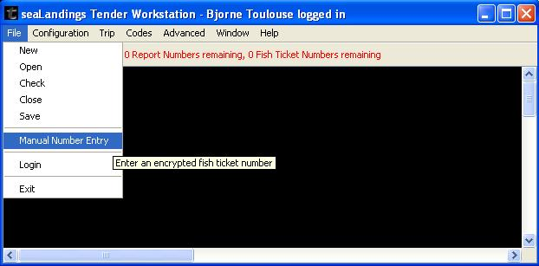
2. Enter your encrypted number, and click OK:
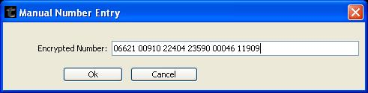
(Note: one encrypted number will hold as many Landing Report Ids and Fish Ticket numbers as you requested, but if you somehow ended up with more than one encrypted number, you can enter the first one, click the Add button, and enter the next one. Clicking OK will process all of the encrypted numbers entered, and click cancel will not process any of the numbers that you added by clicking the Add button.
3. Review - You can see on the tool bar, we imported 4 Report Numbers and 4 Fish Ticket numbers:
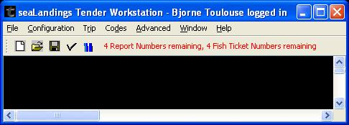

Trouble Shooting:
1. If you try to use a previous days encrypted number, you will get an error message that the encrypted number is stale:
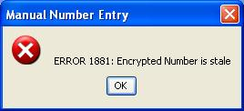
a. This validation occurs to reduce the possibility of reuse of unique Landing Report Ids and Fish Ticket numbers.
b. Stale Landing Report Ids and Fish Ticket numbers can no longer be used, and you will need to request more encrypted numbers from the processing plant.
2. If you try to use an encrypted number that was generated for the operation of another vessel, you will get an error message that the encrypted number is reserved for another vessel:
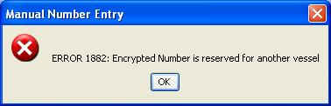
a. This validation occurs to reduce the possibility of reuse of unique Landing Report Ids and Fish Ticket numbers.
b. Encrypted numbers that were generated for another operation of another vessel can not be used, and you will need to request more encrypted numbers from the processing plant. The processor will need to logon to the Processor/Tender Interface with a userid that has a parent operation set up with a relationship to your tender operation.

