eLandings System Generated Reports
tLandings Generated Reports
tLandings is an application developed to enable electronic fish ticket reporting on board tenders without internet service. Tenders are agents for a plant/receiver and document the Fisheries Business License (processor code) of the processor making the purchase and ADF&G vessel license of the agent tender. All tLandings generated reports are based upon this documentation – processor code/tender ADF&G license number. Landing report fish tickets are reported as a single delivery in all dual permit fisheries.
tLandings is primarily used for tendered salmon but is also available for groundfish fisheries. All reports are available for groundfish.
All tLandings generated reports can be displayed and then printed in a PDF format or as an Excel file.
tLandings reports are limited to the data housed on a single thumb drive. If the tender uses more than one thumb drive on a single trip, the reports from the two thumb drives must be manually merged.
Each tLandings generated report is reviewed in our tLandings DVD. For more detailed information, reference this resource.
tLandings Species Summary
This report was developed to provide the tender operator with a simple summary of number and poundage of fish, by species, on board the tender at the point the report is generated. The report can be beneficial when the fleet manager needs to determine the catch on board the tender. This report is dynamically generated, in other words, it can be run again and again, as additional landings occur.
The report summarizes only SOLD catch which is transferred to the tender: sold harvest, overlimits poundage, and confiscated catch. It also includes any and all test fishery harvest. Total dollar amount of all purchased fish, by species, is provided, if prices are documented on the fish ticket.
The report does not include personal use catch retained by the vessel operator, or discards at sea.
Number and poundage of all species, salmon and groundfish, are provided with an additional summary by gear type.
tLandings Species Statarea Summary
The Species Statarea Summary is an expansion of the Species Summary report, which condenses landings by species, gear and area of harvest (statarea). This report was developed to assist processor office staff that summarize harvest from tenders yet to deliver. The report aids in the completion of daily catch reports to the local ADF&G office.
tLandings Personal Use Summary
Some ADF&G area office require daily reporting of not just purchased catch, but also personal use harvest retained by the fisher. This report provides a summary of all harvest by species, gear and area of harvest (statarea). The summary is limited to total number of fish harvested, and includes personal use harvest. Pounds of fish are not included.
tLandings Tender Log
The tLandings tender log was developed to replicate paper based forms use by industry to summarize all landings, contained on a single thumb drive, to the tender for a specific trip.
The summary columns for Mixed Salmon (species code 460), used only in Bristol Bay fisheries, is displayed only if the species is contained on fish tickets housed within the thumb drive.
Landing report fish tickets are summarized by vessel or set net site permit holder’s name, date/time of delivery, statistical area and catch. If a landing report fish ticket document more than one statistical area, the report is list catch summed by each statistical area. Small kings reported using the species code 411 are included in the totals. The report summarizes only SOLD or TRANSFERED catch: sold, overlimits poundage, confiscated catch. It also includes any and all test fishery harvest. The report does not include personal use catch retained by the vessel operator, or discards at sea.
Due to space limitations and a desire to keep all columns on this report to one page, groundfish species that by be bycatch to salmon troll fisheries are not listed.
The tender log header includes the tender vessel by name and number and number of completed landing reports. The number of fish tickets (landing reports) records provided by the tender operator should be checked against the number listed on the tender log and reconciled to each landing report listed on the tender log to assure that all records are submitted to the local office of ADF&G.
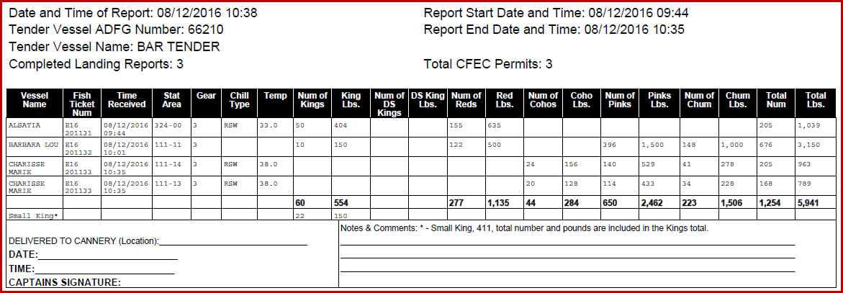
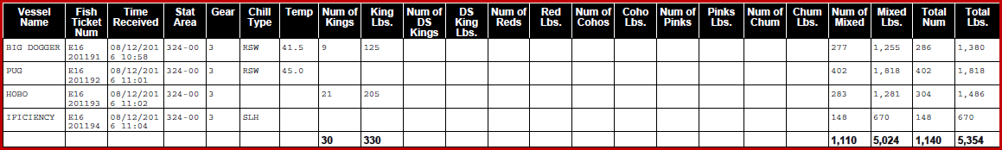
The tender log displayed above illustrates Bristol Bay reports documenting mixed salmon harvest.

Bristol Bay eLandings Generated Reports
The eLandings web application has several reports developed for Bristol Bay processors. These reports are available in the eLandings web application and all landing reports housed in the eLandings database. All reports are based upon the Fisheries Business License (processor code).
Mixed Salmon Update Tool
The use of mixed salmon species code 460, is allowable in Bristol Bay fisheries, as catch is unsorted. The landing reports must be updated, using the Mixed Salmon update tool. Once the sorting and production report is available seafood processing office staff can update each report that contains the species 460 – mixed salmon.
The fish ticket records can be updated using the Tender Batch ID or date range, but works most accurately if completed by tender batch, as production reports most often based on tender offload.
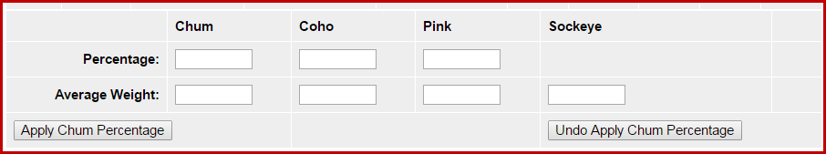
Once the records requiring update are identified and the species composition for the identified tickets has been determined the Mixed Salmon Update can be performed. The report will modify the mixed salmon species (460) to all salmon species, with the exception of Chinook.
Information required to update fish ticket records are:
Total mixed salmon poundage
Upon sorting – percentage based upon weight of chum, coho and/or pink species Average Weight of each represented species, including sockeye

Please note that once the “chum” percentage has been applied, the conversion can be unapplied, if incorrect and reapplied. All harvest transferred to the tender - sold, overlimits or confiscated, with a mixed salmon code, are modified.
All fish tickets are updated with the corrected species comp and available for data extraction and reprinting of tickets. Tickets should be updated using this tool prior to running the Bristol Bay Weekly Report.
Bristol Bay Data Assurance Report
The Assurance Report was developed at the request of Bristol Bay processors to assist them in identifying fish tickets that documented incorrect information. Information contained in the report include:
    - Date fishing began
    - Date of landing
    - Time of landing
    - Statarea of harvest
    - Gear
    - Landing report id
    - Fish Ticket Number
    - Fishery (as defined by district and gear)
The procedure used by processors is to generate the Bristol Bay Weekly Report and if discrepancies are identified, run the Data Assurance Report to identify the specific report(s) containing incorrect information. The ticket(s) is corrected and the Bristol Bay Weekly Report generated from eLandings again.
Bristol Bay Weekly Report
The Bristol Bay Weekly Report electronically replicates a paper report used by ADF&G staff for in-season management. This weekly report is generated from eLandings landing reports that have been updated from mixed salmon to unique salmon species. The week is defined as Sunday thru Saturday. The report summarizes harvest for each day of the reporting week as follows:
- Number and pounds of each species
- Chum Percentage, determined by the ratio of the number of sockeye salmon to the number of chum salmon
- Number of deliveries to tender vessels or dock/buying stations, represented by fish ticket reports
- Average weight of fish by species

Fish ticket reports are sorted by the processor by district and day and submitted with the Bristol Bay Report. Upon receipt, local ADF&G office staff review this report and verify that all fish ticket records have been submitted within the required time period.

Harvest identified by the Management Program TEST is summarized separately.
Bristol Bay Season Summary Report
This report duplicates a paper reporting format required for all processors to complete at the end of the commercial fishing season. This report summarizes all purchased salmon, by species. The summary is by salmon district and day, documenting the total number and pounds of each salmon species. This report is not completed until all mixed salmon species harvest has been revised using the Mixed Salmon tool.
The report includes a chum percentage, determined by the ratio of the number of sockeye salmon to the number of chum salmon. The report does not include personal use harvest, but does include overlimits and confiscated harvest.
Harvest identified by the Management Program TEST is summarized separately.
eLandings Data Extraction – Customized Reports
The eLandings web application provides an interface to search for and retrieve finalized landing report and production report data from the eLandings database. Using this feature you can extract multiple Landings or Production Reports from eLandings at the same time. The data is retrieved by the Processor Code or the Federal Permit Number. The Report Extract page provides users with the ability to extract these reports in three different formats, XML, CSV, or EXCEL.
In addition to the report extract feature, users can download and customize fishery specific landing and production report templates, providing a consistent output of the information pertinent to the end users' needs.
Detailed information on the Data Extract tool is available at: https://elandings.atlassian.net/wiki/display/doc/Report+Extract+Tool

eLandings Generated COAR
The COAR reporting process has been incorporated into the eLandings System to provide more efficient and more accurate reporting. As fish tickets are required for the first purchase of seafood product, a summary of all purchases can be generated from the eLandings System for those processors using this system, fully and even partially. The summary is available for each unique operation, that is, each unique entity with a Fisheries Business license.
The eLandings/COAR reporting process allows industry to extract all buying activity, including custom processing performed for you as the owner of the product, by COAR areas of purchase. Once this information has been generated within the eLandings System, the designated seafood industry staff person shall add any non-eLandings fish ticket purchase information, ex-vessel pricing, and production information. Post-season price adjustments can be added, when available. The COAR is now submitted electronically.
Detailed information on the eLandings generated COAR is available at:
https://elandings.atlassian.net/wiki/display/doc/Commercial+Operator%27s+Annual+Report+-+COAR+-+User+Documentation+and+Downloadable+Video

