Fish Tax News

The Fish Tax Group of the Alaska Tax Division is currently working on adding an online taxpayer application for Fisheries related taxes we’ve named, Revenue Online. This new online service will go-live February 22, 2016.
Revenue Online Features:
- File Tax Return
- Amend a Tax Return
- Apply for License
- Request an Appeal
- Pay Tax Liabilities
- View Current Account Balances
- Correspond Quickly & Securely with Tax Division
- View Correspondence with Tax Division
- Update Account Information: Addresses, Phone Numbers

Please check the TRMS page on the Tax Division's website for additional announcements at www.tax.alaska.gov.
--Sample Web Page of Revenue Online--
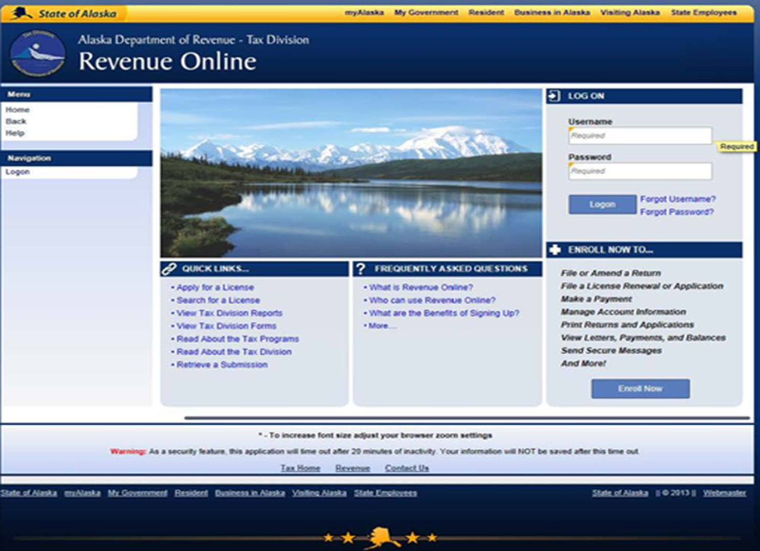

Following the rollout of Revenue Online on February 22nd, fish taxpayers will need to enroll to submit new license applications and file tax returns. For more information please review the instructions posted on DOR’s Revenue Online system located at: http://www.online-tax.alaska.gov/ATP/WebDoc/.

If you have any questions, or would like additional information please don’t hesitate to contact the Fish Group at 907.465.2320 or write us at dor.tax.fishexcise@alaska.gov.

