eLandings for Salmon Annual Workshop
November 16, 2015
9:00 am to 5:00 pm
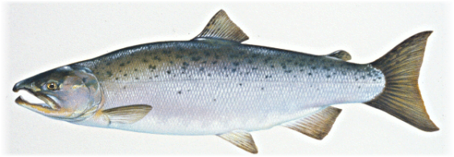
Silver Cloud Hotel – Lake Union
1150 Fairview Avenue North
Seattle, WA 98109
206-447-9500
Training Objectives
To provide participants with ~
a comprehensive review of all aspects of eLandings as it relates to salmon catch reporting;
a review of all application enhancements for 2016, completed or planned;
a review of training and user support resources;
a review of the eLandings integrated COAR;
a review of ADF&G web resources;
an opportunity to ask questions, provide feedback and exchange information, as well as;
an opportunity to meet the eLandings management team and other end users.

Participants: Gail Smith, Ammon Bailey, Jennifer Shriver – ADF&G Juneau
Tommy Sheridan – ADF&G Cordova

9:00
Housekeeping and Introductions - Gail
eLandings Operations and User Accounts – Ammon

Custom Processing for tenders – Ammon

tLandings/eLandings Data Flow – agency fish ticket processing – Gail

Processor Tender Interface Review - Gail/Ammon
- What does it do and why a new application each year?– Gail
- The PTI download and scan to remove prior versions – Ammon
- PTI demo to configure a thumbdrive– Gail
10:40 Break

11:00
tLandings Review – Ammon
- How to complete one salmon report ticket – Ammon
  - Record Average Weight
  - Record unique statarea on line item
- How to complete a salmon troll ticket – Gail
- Documentation of dual permits – Gail
- Review of reports –Summary Reports and Tender Log in tLandings – Gail
- Summary re-cap of what has changed in tlandings – Ammon
- tLandings for groundfish – Gail

12:00-1:15 Lunch

PTI data uploaded – Gail
- How to modify a processor code during the upload in PTI
Salmon 2015 tLandings Support issues
- Network installation of PTI / machine permissions - Ammon
- Using prior year tlandings - Ammon
  - Delete old thumb drives and re-install PTI
- Corruption of thumb drives – Ammon
- Number reuse - Ammon
- Duplicate ticket submission – Gail
  - Discussion of why this occurs
- Data Correction and updates – Gail
  - Mass Salmon Update tool enhancements
  - eLandings updates
Data Extraction Tool review – Gail
- Results emailed
- Web Services – Ammon
  - Schema Changes to XML
Salmon Reports – Ammon
- Bristol Bay Report
- Mixed Salmon Update
User support
  - Training and training resources - Gail
  - Confluence - Gail
  - FAQ’s - Gail
  - Never copy thumb drives - Gail
  - Help Desk and email - Gail
  - Mass Salmon Updates - Gail
  - Programmer support – Ammon
Equipment issues
  - Recommendations - Ammon
  - Seasonal procedures - Gail

3:00 pm Break

3:20
Reporting Expectations – Thomas Sheridan
- How fisheries are managed with the data you provide
- Timely upload of thumb drives
- Accurate average weights
- Submission of signed copies of fish tickets to ADF&G
3:40
ADF&G Reporting Regulation 5AAC 39.130 – Jennifer Shriver
eLandings Integrated COAR reporting – Jennifer Shriver
Department of Revenue on-line licensing system – Jennifer Shriver
ADFG Web Resources – Jennifer Shriver
4:45 pm
Additional questions, concerns, comments

