eLandings Simple IFQ Landing Report

Simple IFQ Landing Report
Go to: http://elandingst.alaska.gov/elandings/Login
Enter the following user ID and password:
UserID | Password
DVARDEN | D_varden

IFQ and Groundfish Landing Report
On the main reports page of eLandings, you should see The Pisces Plant in the Operation field
- Click on the Groundfish Landing Report button.
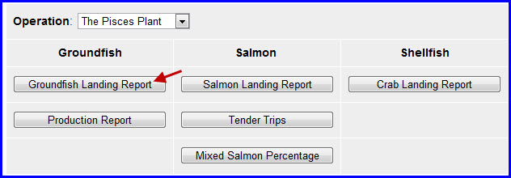
1. Enter vessel and fishing trip date values:
ADF&G Vessel Number | ADF&G Gear Code | Crew Size | No. of Observers
33697 | 61 | 3 | 0
Date Fishing Began | Days Fished | Date of Landing
3/xx/2016 | 3 | 3/xx/2016

Leave the rest of the fields as they are, filled in with their default values.
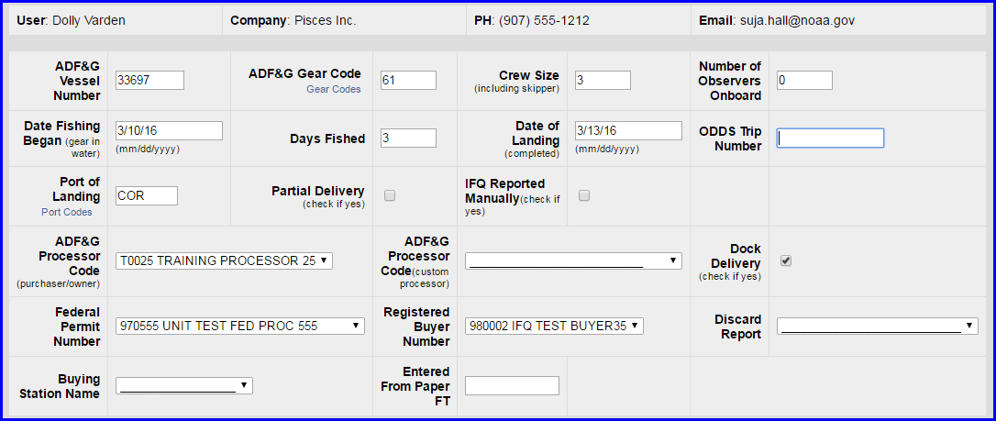

2. Scroll down to the CFEC Permit Worksheet. Enter the following permit and species values.
CFEC Fishery | Permit No. | Permit Sequence
B61B | 00101U | 1601S
Management Program | Program ID | Percent
IFQ | leave blank | leave blank
CFEC Permit Holder's NMFS ID | IFQ Permit | Species
980001 | 980003 | 200
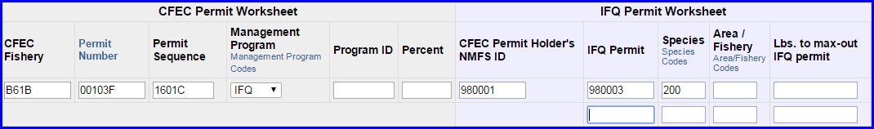

3. Scroll down to the Stat Area Worksheet. Enter the following State statistical areas and percentages and then Click Save.
Stat Area 1 | % | Stat Area 2 | %
515730 | 85 | 515700 | 15
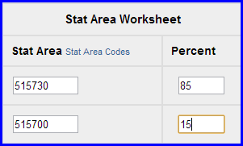

Adding Catch Information
- Click on the Add/Edit Itemized Catch button
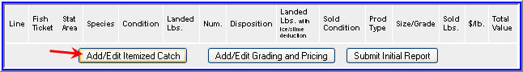
- You do not need to select the fish ticket number at this point; you can use the Allocate Permits function after you save your catch information.
- Enter the following species, condition codes, weights, and disposition codes. Click Save.
Species Code | Condition Code | Weight | Weight Modifier | Disposition Code
200 | 04 | 7215 | w/ice and slime | 60
145 | 03 | 250 | None | 95 (retained for personal use)
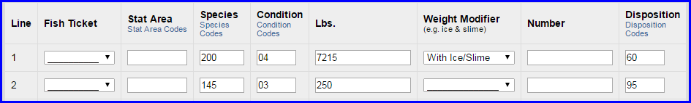
- Click on the Allocate Permits button in the CFEC Permit Worksheet window.

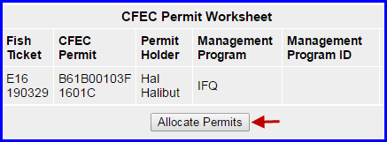
- Click on the Submit Initial Report button

IFQ Reports
- Scroll down to the bottom of the screen and click on the Generate IFQ Reports button.
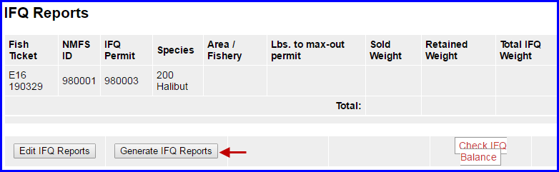
- Notice the status of your IFQ reports state "Not Submitted", this means you have not yet submitted your IFQ Report so carefully review the data.
- Verify that your IFQ information is correct and then click on the Submit IFQ Reports button.
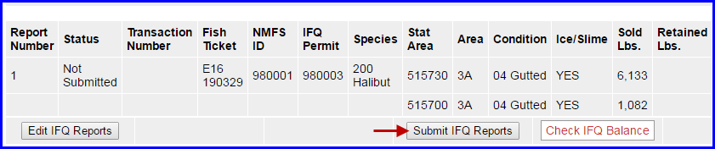
NOTE: In the training environment you will always get a red line error telling you to contact NMFS Enforcement, disregard in this instance.

At the top of the Groundfish Report Display screen you should see an information message that states "IFQ reports submitted".
- Click on the Add/Edit Grading and Pricing button.

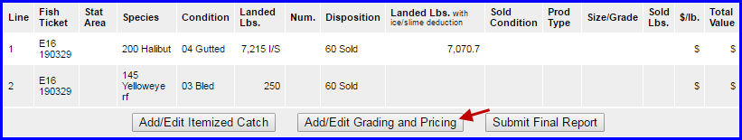

Enter the following condition codes, product types, sizing and grading information, sold pounds, and price per sold pound. Click on Save.
Species | Sold Condition | Product Type | Size/Grade | Sold Pounds | $/lb
200 | 05 | P | 10-20 | 5200 | 4.00
200 | 05 | P | 20-30 | 2015 | 4.25
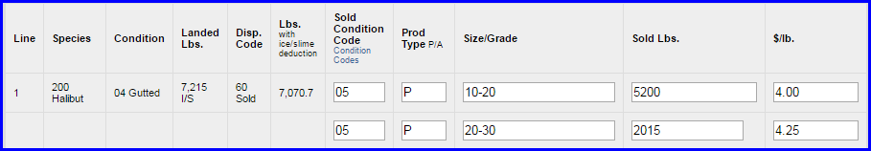

You will be taken back to the main report screen. Click on the Submit Final Report button.

At the top of the report screen verify the report status says Final Report Submitted.
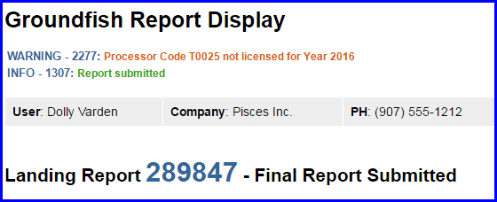
Now that you have Final Submitted your report, you only have a few things left to do.
1) Print your landing receipt by click on the View Receipts to Print button at the bottom of the reports page
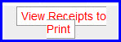
2) Print your fish ticket by locating the CFEC Permit Worksheet box and clicking on the fish ticket number in blue text
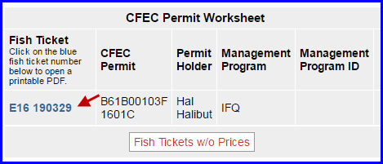
3) Print your Observer Fee PDF by clicking on the View Observer PDF button
