**eLandings Operations Administration**

The eLandings system was recently restructured to allow our end users to better manage dependent operations, such as custom processing and tenders.

If you are an administrative user, you will notice that the eLandings main menu now includes the selection, **Administer Operations**.

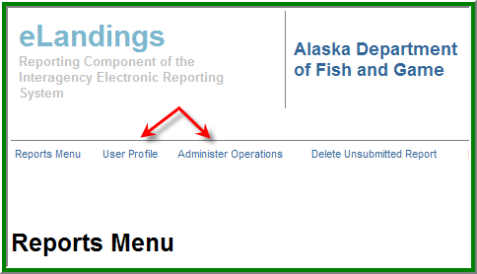

The User Profile continues to be fully available to all authorized users of the eLandings system and provides the ability to customize the display of the eLandings data entry screens, decimal displays, and printing options.

We always recommend that end users review the User Profile annually to make certain the application meets your expectations. The User Profile settings are unique to each end user, allowing you to customize the application.

Just as a reminder, an **operation** is defined as an entity that will receive seafood product and will complete landing and production reports, as well as IFQ reports, and has a unique and valid Fisheries Business License – Processor Code. For the purposes of this document, we will refer to this operation type as a **parent operation**.

A parent operation can be a plant receiver, an at-sea processor, or a buyer/exporter. A parent operation may have **dependent operations** that share the same processor code. Dependent (child) operations include buying stations, tenders and custom processing relationships.

With the expansion of dependent operations, the display of these categories became visually confusing. The restructured operation administration now uses a tree structure to display the parent operation and the child operations.

In the following example, King Crab Processing USA is the *parent operation*, with *buying stations*, *tenders* and *custom processing done* by relationships. Management of these operations will be discussed in detail later in this document.

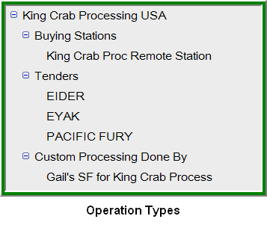

The User Profile allows you to set a default operation.

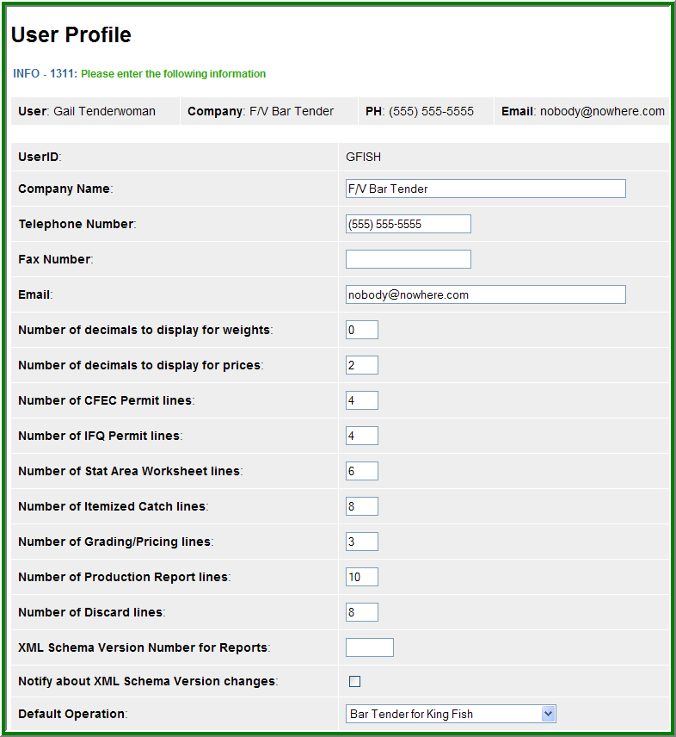

Note the Default Operation at the bottom of the screen display, above. If you are authorized for more than one operation, you can select the default operation that is displayed when you first login to eLandings.

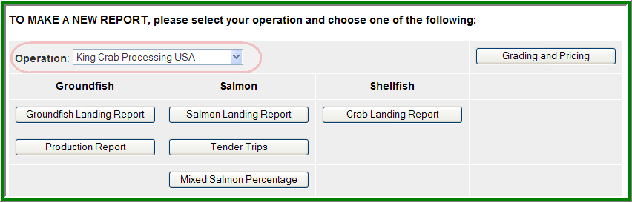

Processors with more than one processing facility frequently have users that are authorized for multiple operations.

Also note the Grading and Pricing button directly across from the Operation selection, upper right hand corner of the display above.

**The Operations Main Menu**

When you select Administer Operations from the Reports Menu, the Operations and Users page will display.

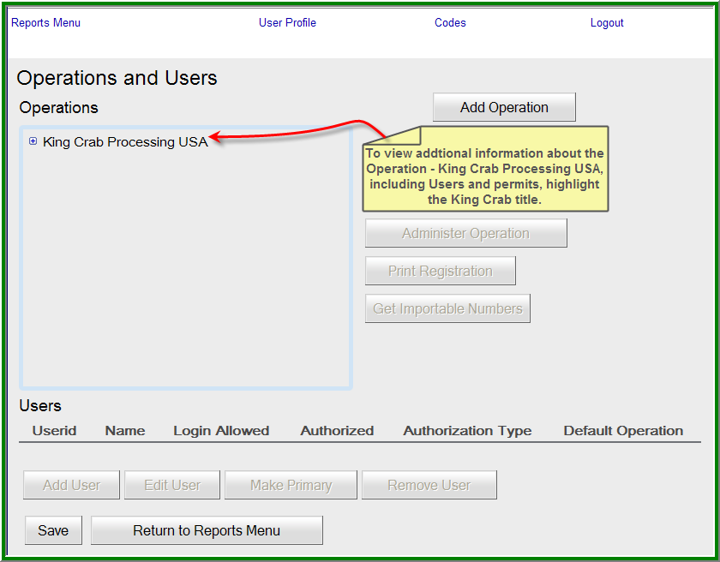

Depending on the number of parent operations you are authorized to administer, one or more parent operations will be displayed on the main menu.

To display the operation permit profile, simply click on the name. This action displays operation details; all users associated with this operation, and allows for the addition of dependent operations and management of users.

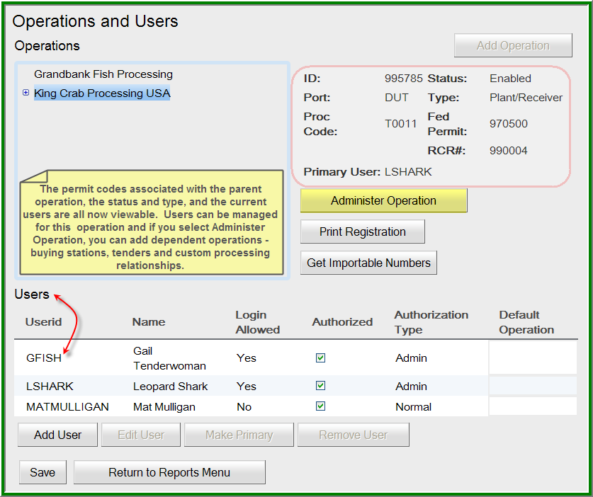

As you review the screen shot display above, note the + symbol to the left of King Crab Processing.



This + symbol indicates that this operation has dependent operations. Grandbank Fish Processing does not currently have dependent operations.

**View and Add Dependent Operations**

When you click on the Administer Operation button, all child (dependent) operations of the parent are displayed.

 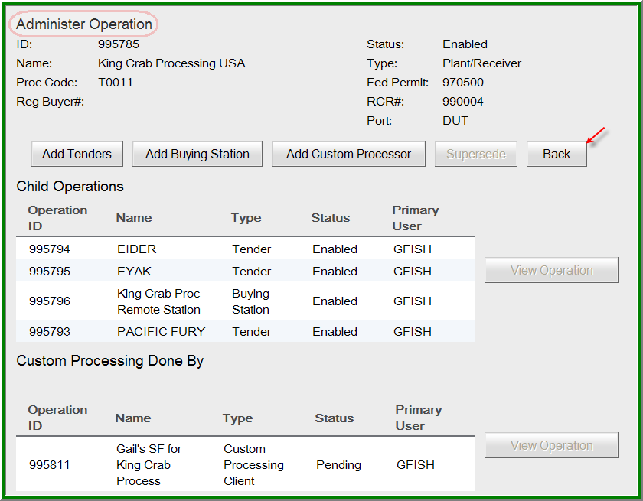

From this application screen you can add tenders, buying stations and custom processors. Note the Back button, which will aid you in navigation thru the Operation features of eLandings.

To add a tender simply click on the Add Tender button. You have two methods to add tenders, but we recommend the Expert Mode. To add tenders you will need the vessel name of each tender and the correct ADF&G vessel license number.

Note the users below this list of tender operations. These are the authorized users for the parent operation. You can add one of more of these users to each of the tender operations by simply clicking the check box. We recommend at least two users for each tender account.

All tender operator user accounts are established and managed in the Processor Tender Interface (PTI) application. The tender operator user accounts only provide access to log into the tLandings application on the thumb drive. **DO NOT ESTABLISH USER ACCOUNTS FOR TENDERS. THIS IS COMPLETED WITHIN THE PROCESSOR TENDER INTERFACE.**

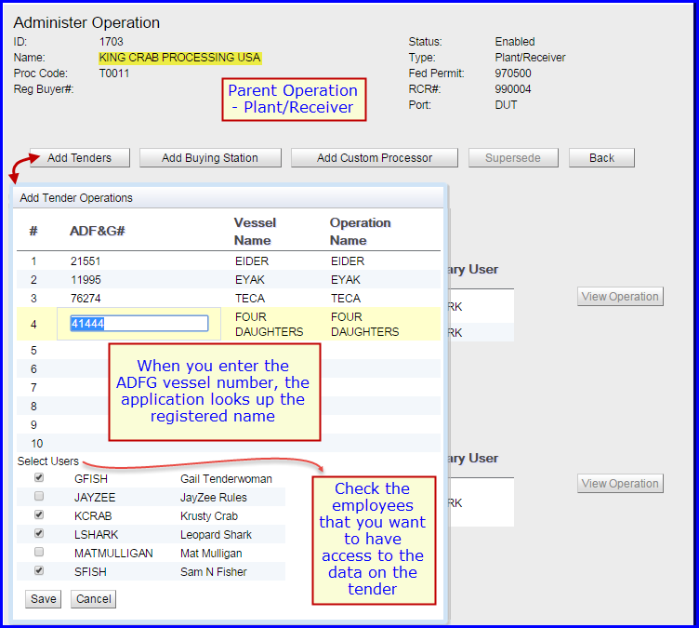

The process of adding a buying station is quite similar. If the buying station will receive IFQ crab, a unique Registered Crab Receiver number must be provided. A Vehicle License Number is not a required field, but must be completed if you are a vessel applying for a federal fishery permit and you do not have USCG documentation.

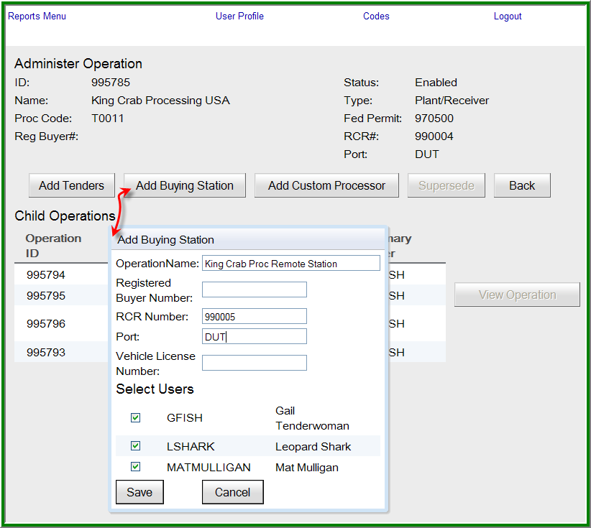

We have added an additional piece of information to the Operation Administration – the **Operation ID**. All parent and child operations are now assigned a unique operation ID. This ID can be helpful in autofilling the permit profile of the operation that will provide custom processing.

When creating a custom processing relationship you have two options:

1. Manually enter all necessary permits related to the processing operation (Figure 1)
2. Simply enter the Operation ID (Figure 2)

Figure 1 - Creating a custom processing relationship – manual entry of the necessary permits: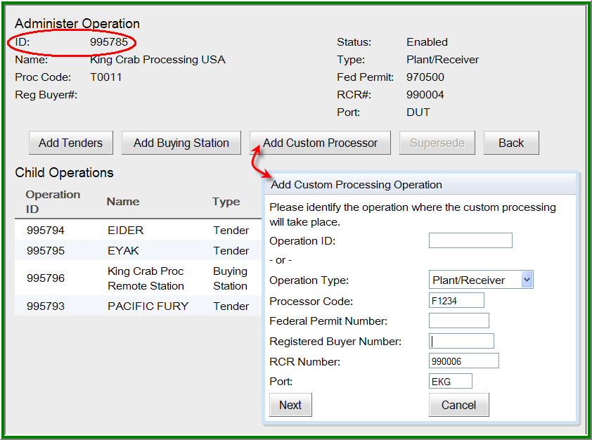

Figure 2 - Creating a custom processing relationship using the Operation ID: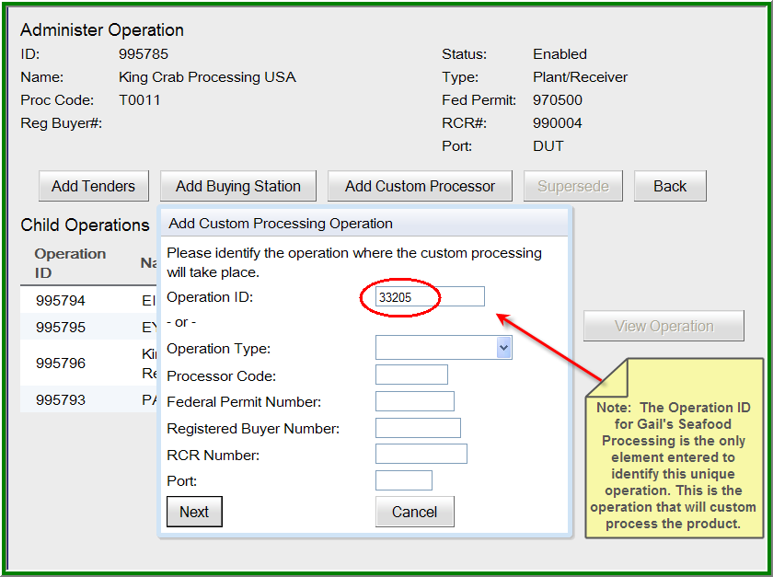

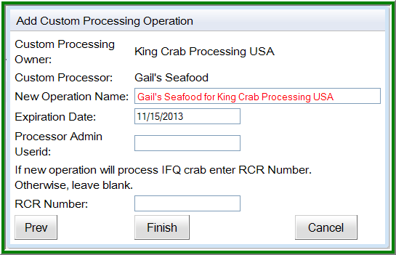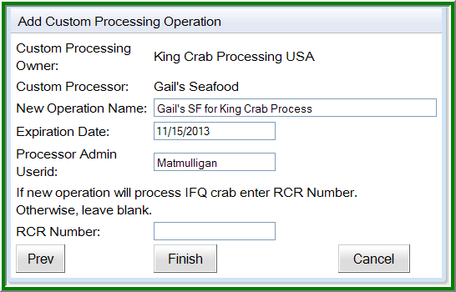

The custom processing relationship is established, but the New Operation Name needs to be reduced to meet the character limitations.

**NOTE:**

Another significant change in the administration of operations is the status. After consultation with the State of Alaska Department of Law, it was determined that **only one User Agreement needs to be established with each parent operation.** The User Agreement shall be reviewed and signed by the plant manager and covers all dependent operations and all authorized users. **All current operations shall be grandfathered into this modification of the User Agreement.**

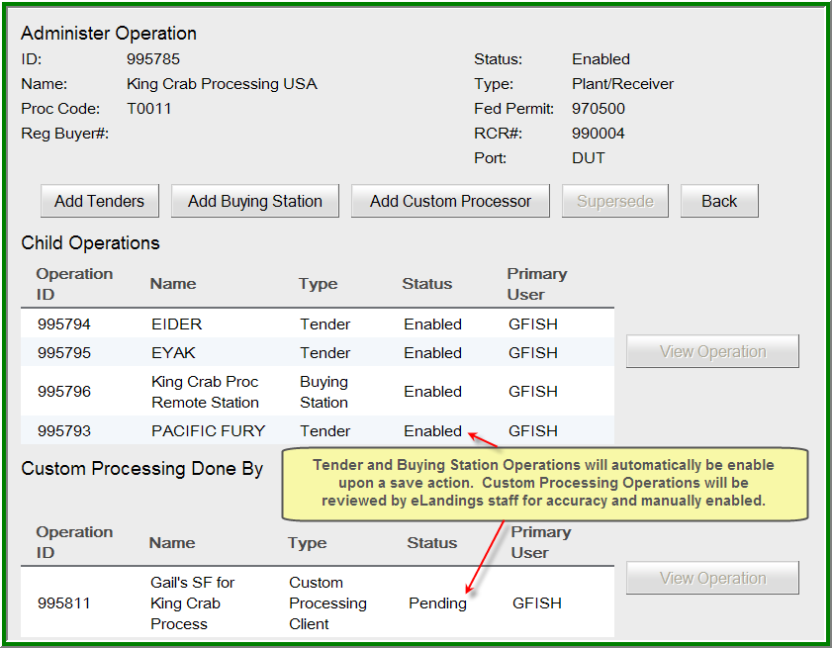

The new User Agreement is attached to this document. Please review. If you have any questions, please contact [eLandings@alaska.gov](mailto:eLandings@alaska.gov).

All dependent operations and all users will automatically be enabled, with the exception of the Custom Processing operation. This operation does need to be reviewed by the eLandings support team prior to use. **Please continue to contact** [**eLandings@alaska.gov**](mailto:eLandings@alaska.gov) **for review of this operation and to enable the custom processing operation.**

**Navigation in the Operation and Users Tree Structure**

The **+** symbol indicates that dependent operations are attached to the parent operation or dependent operation category. To view the simply click on the **+** to display the-.

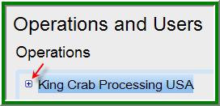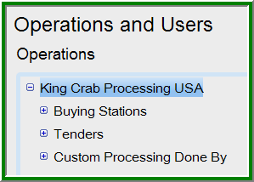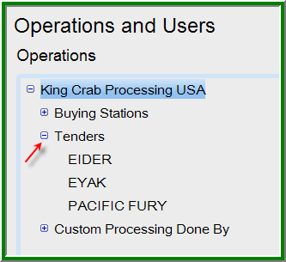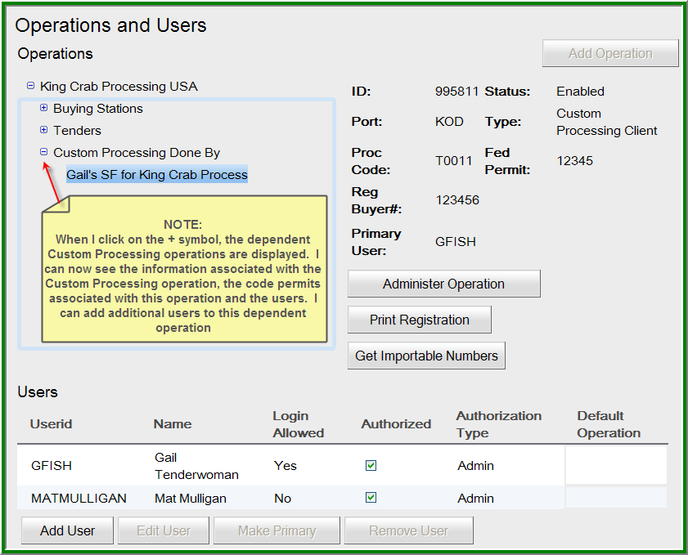

To close the display, click on the **–** symbol.

**Adding Users to an Operation**

To add a user to a primary or dependent operation, such as a tender, using the tree structure, click on the + symbol next to the Tender operations, click on the specific tender you want to add the user to

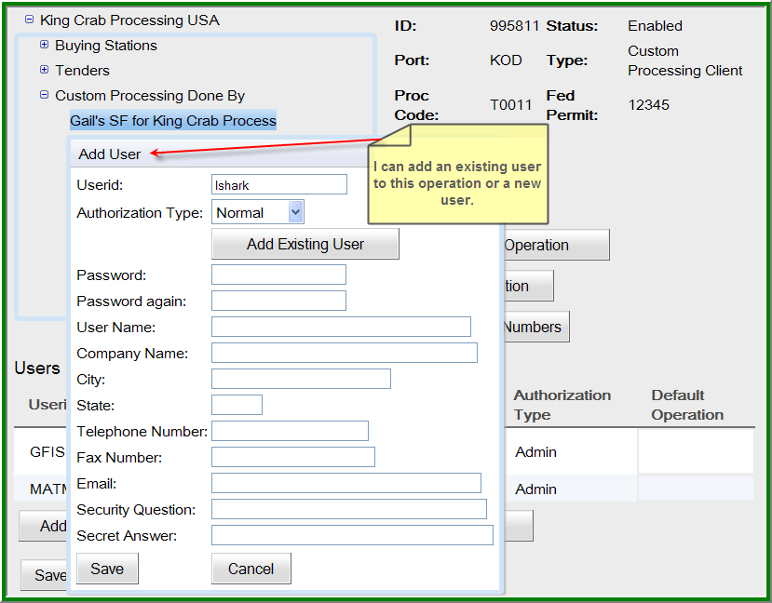

Choose the authorization type and an existing user is added to the operation. Note you can also add a new user in the same dialog box.

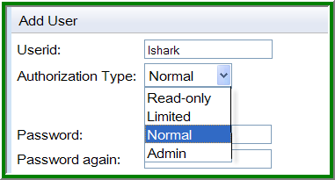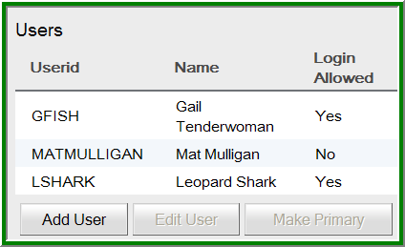

New users can be added by completing the information displayed in the screen shot above. Always remember to save this information to the eLandings database.

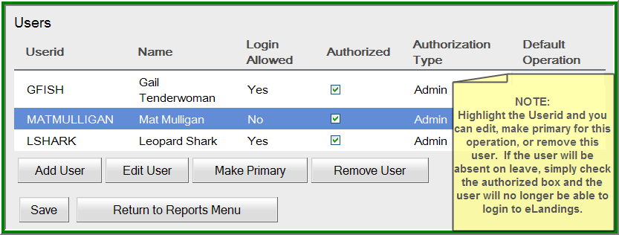

When an existing or new user is added to an operation, such as JayZee (below), **the user is automatically authorized.** **You do NOT need to have a user agreement signed and submitted to National Marine Fishery Service or the Alaska Department of Fish and Game for final authorization.** We do suggest that you have the new user read the eLandings User Agreement, as the processors and the employees for the processor are expected to comply with the agreement.

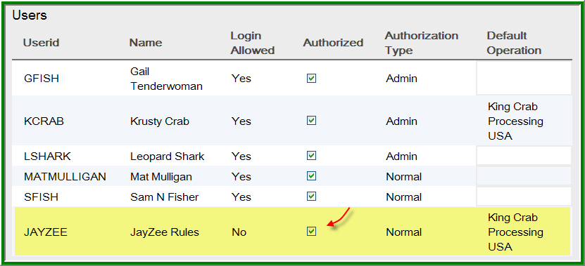

If JayZee is a seasonal employee, you can simply unclick the authorization and access to the eLandings System is temporarily unavailable. When he returns from seasonal leave, check the authorization box. If he leaves employment with your company, highlight his user account record and select the ‘Remove User’ button.

**View Operation Characteristics**

To view the characteristics of any operation, highlight the Operation and the View Operation button to the left of the list becomes active. Click this button and the Operation profile is displayed.

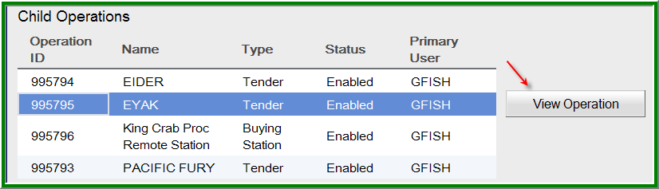

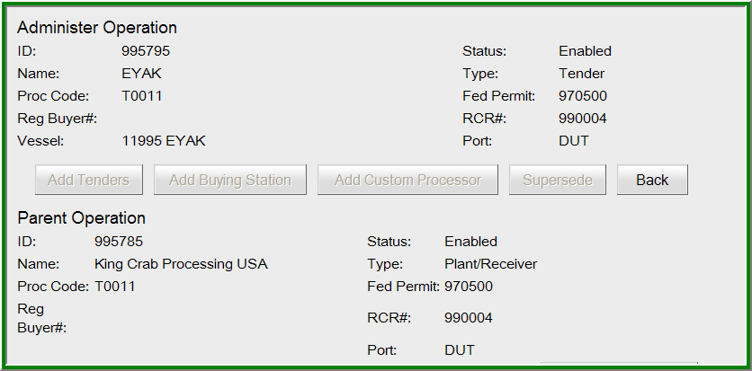

Note the Back button on the right of the screen display. You should use the back button as your navigation aid in the Operations features. When you reach the main page of the Operations and Users page, the back button disappears and a Return to Reports Menu appears.

**Adding a New Independent Operation**

When you first open the Administer Operations page, the Add Operation button is active. This allows you to add new ***independent*** operations. DO NOT USE THIS FEATURE TO ADD DEPENDENT OPERATIONS. PLEASE FOLLOW THE SETS ALREADY COVERED IN THIS DOCUMENT.

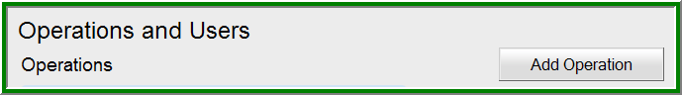

To add a new independent operation, select the Add Operation button on the Operations and Users main page.

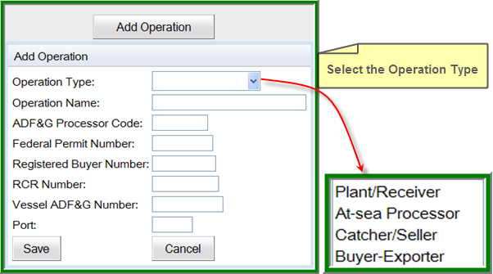

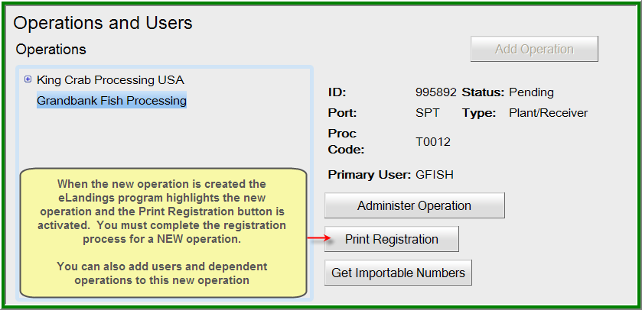

**Adding Tenders in the Prompted Mode or Expert Mode:**

You can add tender operations in the prompted mode, step by step, with explanations, or the expert mode.

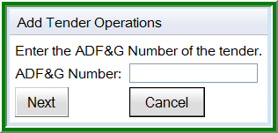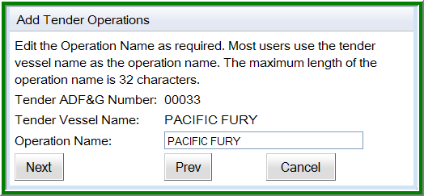

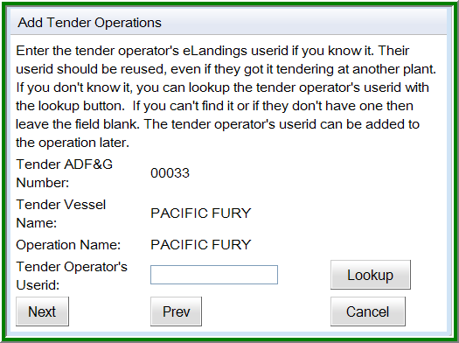

‘Expert Mode’

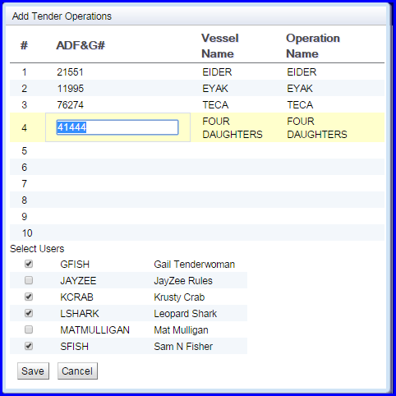

The Expert mode allows you to add up to 10 tenders, at once. Identification of the Tender Operator with a User id is not needed as these accounts are established in the Processor Tender Interface (PTI) application only. You can add office staff to each of these operations, by checking the box below Select Users. In this example, Gail Tenderwoman will be added to each tender operation.

**Tender user account management within the PTI:**

All tender operator account user ids are now defaulted to TENDERMAN. Passwords are documented and available to authorized seafood processing staff from the PTI. Open the PTI, login with your plant receiver user account and locate the menu selection in the upper left hand corner, Advanced. Select Manage tLandings User Passwords.

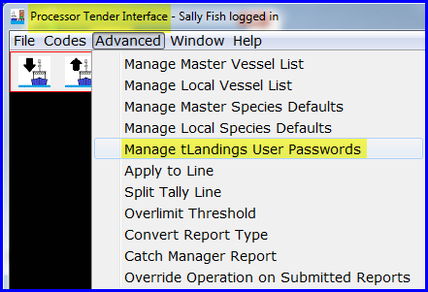

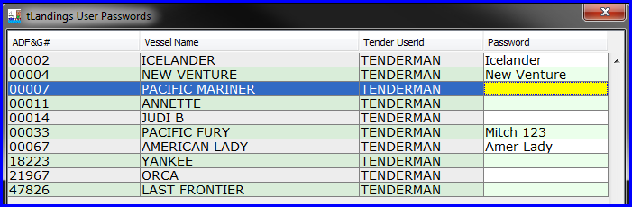

The tender list will auto load. Note that all tender user ids are TENDERMAN. This user id will auto load when tLandings is opened. Just click on the password cell and add the password. PLEASE REMEMBER THAT PASSWORDS ARE CASE SENSITIVE.

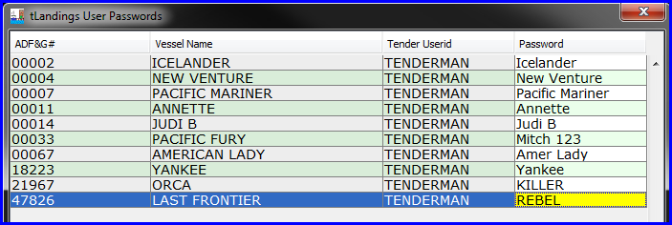

Once completed, save the list. It will always be available for reference from the PTI. You can change the password, but all thumb drives with the old password will need to be reconfigured.

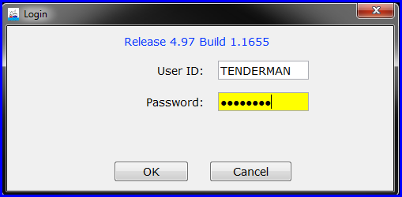

**OFFICE STAFF MEMBER WITH A USERID AND PASSWORD FOR ELANDING OR THE PTI SHOULD NOT SHARE THESE ACCOUNT AUTHORIZATIONS WITH TENDER OPERATORS**

**Note** that for the administrative user who is logged in and adding the tenders, their userid will be added to the tender operations whether or not the checkbox by their userid is checked. However, it is a good practice to always make sure the checkbox by your userid is checked.

C:\Documents and Settings\pgsmith\Local Settings\Temporary Internet Files\Content.IE5\M71ZPBU6\MC900059919[1].gifC:\Documents and Settings\pgsmith\Local Settings\Temporary Internet Files\Content.IE5\RZC6P1V9\MC900440193[1].wmf

The administration of operations is complex and does require periodic review. Please retain this document and never hesitate to contact us if you have questions or need assistance at [eLandings@alaska.gov](mailto:eLandings@alaska.gov) or (888) 443-5726.