2017 PTI and tLandings for Salmon and Groundfish User Documentation
The 2017 Processor Tender Interface (PTI) application used to configure thumb drives for groundfish and salmon is now available for download at: https://elandings.atlassian.net/wiki/display/doc/2017+tLandings+Processor+Tender+Interface+%28PTI%29+Installer+Download . We recommend that you print this document, as it provides detailed information and application screen images. This is a full summary of the changes we have made to the PTI and tLandings recently. Please read carefully and retain as a resource.
The PTI prepares thumb drives for tenders and buying stations, loading the tLandings application with your business permit and license codes. Each year, you will need to refresh the PTI to obtain the most recent updates and improvements to both the PTI and tLandings. As the tLandings application has also changed, you will need to make certain that all thumb drives used with the tLandings application have had all files deleted. In other words, all thumb drives should be empty.
If you downloaded the 2017 PTI for groundfish use prior to this email, please download the newest PTI – 4.97 – 1.2900 at any time prior to your need for configured thumb drives for salmon. We have made additional changes to both the PTI and tLandings and they are only available when you download the newest version. The PTI icon will remain identical but will link to the latest version of the PTI.
As mentioned, the desktop icon will remain the same when you download the latest version of the PTI. What will change is the release and build numbers that display when you first log into the application. Please check to make certain you have the currently recommended version. We recommend, when you install the new version of the PTI to scan and remove all prior versions of the application. This should remove all older PTI icons. If the scanning process did not do so, they should be deleted.
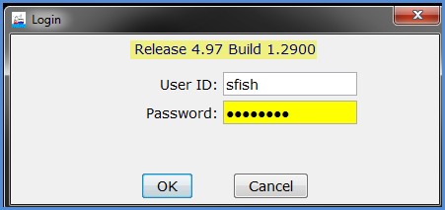
The login dialog box will include the Release and Build number. Please check prior to use.

This action will assure that tickets generated in the tLandings application are identified with the E17 unique number identifier.
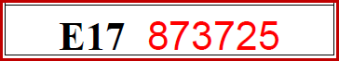
Changes to tLandings and the PTI for 2017
The PTI and tLandings have changed in five major ways:
- CFEC PERMIT AND VESSEL DATA CAPTURE - Both CFEC permit and vessel information is now captured when you complete a successful swipe of the permit.
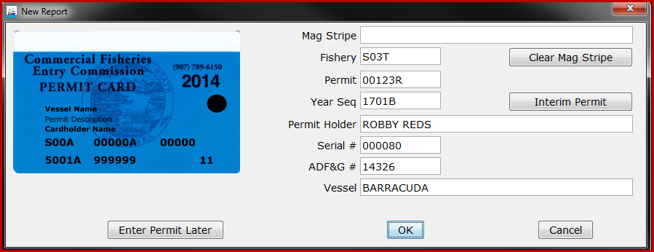
- Vessel Lists and Vessel Pick Lists - Because the application now harvests the vessel information from the CFEC permit card, you no longer need to develop and manage a vessel list(s). Tender operators will need to make certain that the vessel information listed on the permit card and stored on the magstripe is correct, as vessels can change once the season begins.
- Setting and Customized Display - The tLandings application was designed to provide a reporting tool for all salmon or groundfish fisheries. This has meant that the application has data entry fields that do not pertain to regional fishery requirements. To simplify reporting and unclutter the tLandings application entry screens, we are now providing the option to customize the display of fields. Below are illustrations of the non-customized and customized data entry screens.

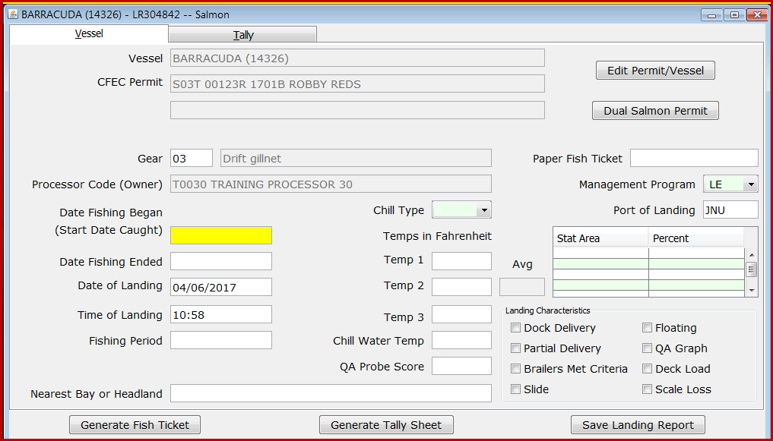
Standard Display
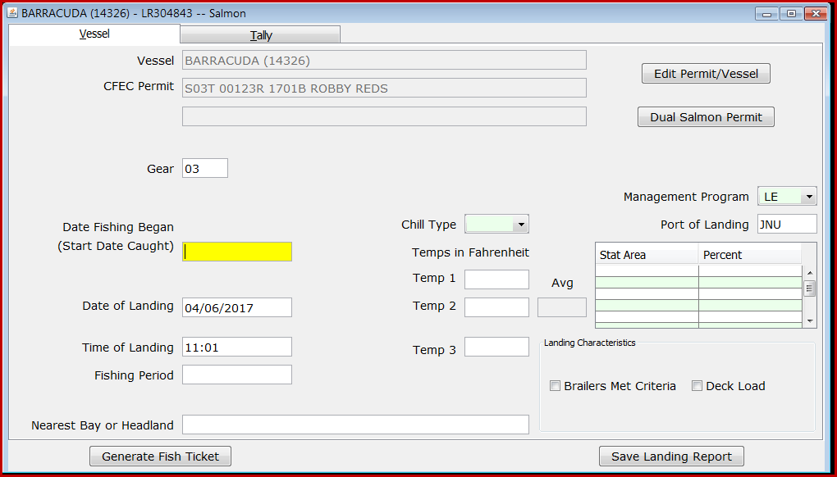
Customized Display

- Tender Operations Management - We have also simplified the establishment of tender operations and the selection of tenders within the PTI.
When you initiate preparing the thumb drive(s) for the tender, select the down arrow located in the upper left hand corner.
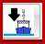
A dialog box appears allowing you to choose your operation and the tender.
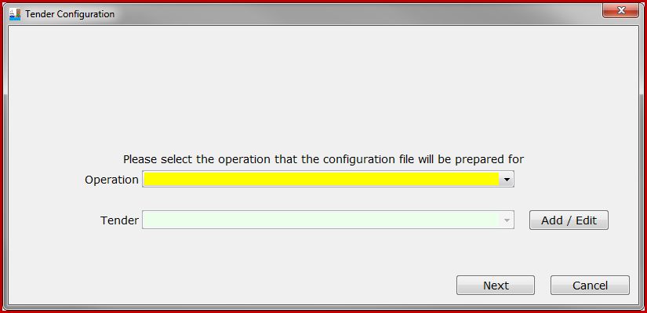
Note the Add/Edit button next to the Tender selection, which allows you to add additional tender operations.
- Additional Groundfish Data Elements - tLandings for groundfish has been modified to requiring documentation of the new data elements.

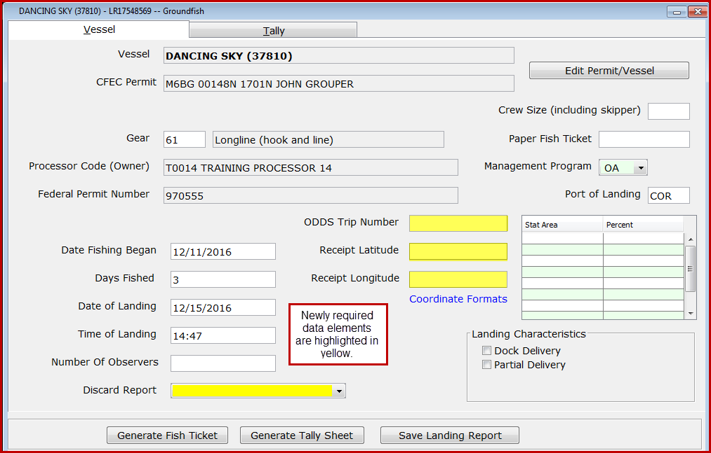

All of these changes will be covered in this document, in detail.

CFEC PERMIT AND VESSEL DATA CAPTURE
The eLandings team have modified the tLandings application to harvest both the vessel and permit information from the CFEC permit card. To accomplish this, we have changed the initial application navigation. When you start a new landing report by clicking the new page icon , a New Report dialog box appears ready to accept the read from the mag stripe reader.
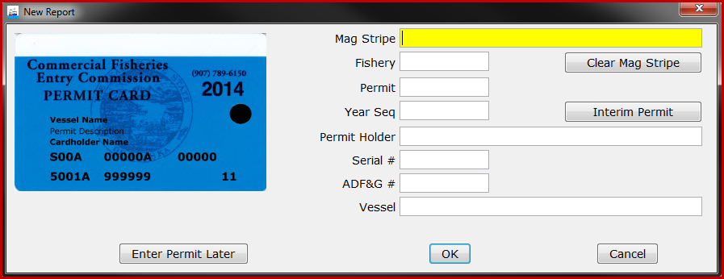
Once the mag strip is read, the fields are populated. Please verify that the vessel name and ADF&G number are correct. This is especially important in groundfish fisheries.
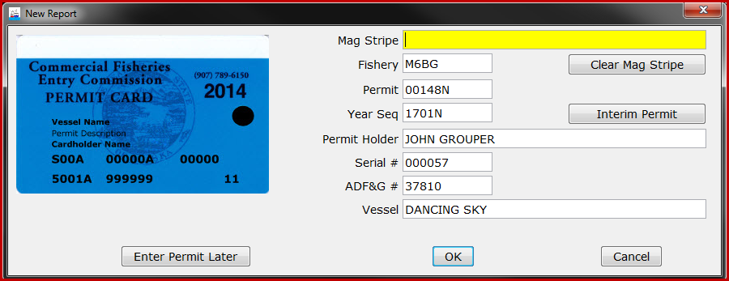
If the mag stripe reader does not properly record the permit and license information, just click the Clear Mag Stripe button and try again. The information can be entered manually, as well. If the permit is not immediately available, click the Enter Permit Later button.
Vessel Lists and Vessel Pick Lists

Because the application now harvests the vessel information from the CFEC permit card, you no longer need to develop and manage a vessel list. A vessel file(s) is no longer stored on the tLandings thumb drive and no longer needs to be updated.

When the CFEC permit card is swiped, the vessel information can still be edited. The Edit Permit/Vessel button takes the user back to the initial dialog box to make corrections.

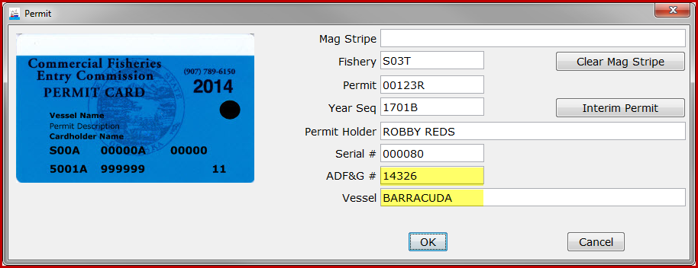
Initial magnetic card swipe information
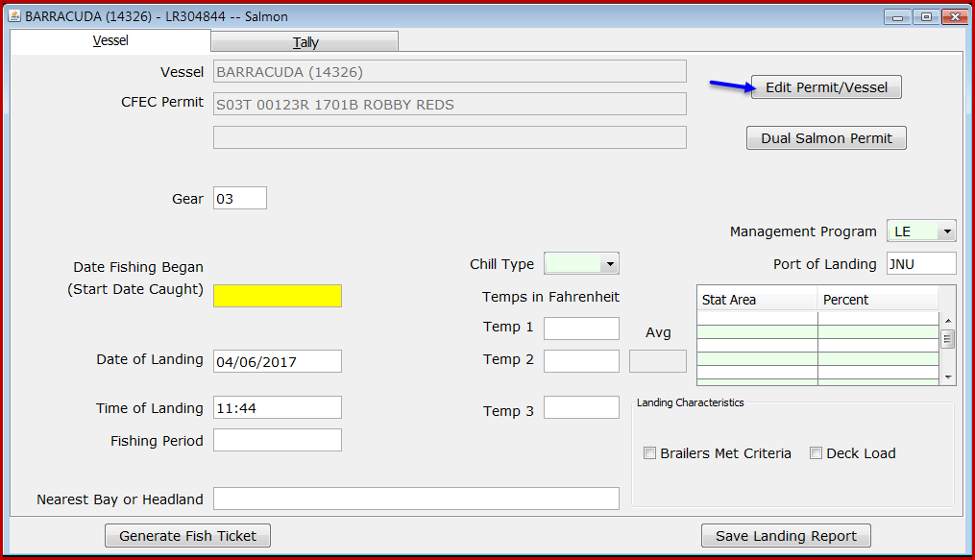
Edit Permit/Vessel Button
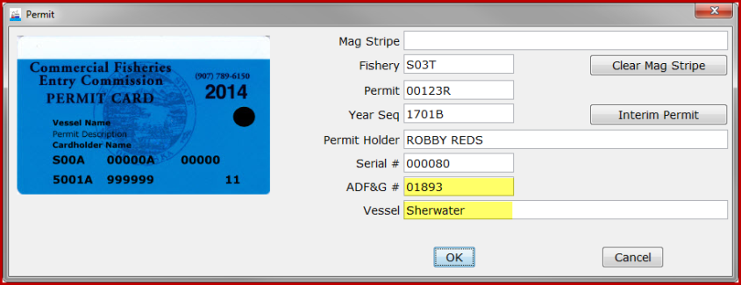
Revised vessel information

NOTE: Correct reporting of the ADF&G vessel, permit number and name is a regulation requirement. Tender operators should not assume that the vessel information embedded in the magnetic strip on the permit card is current. Both the tender operator and the permit holder should review this data element during to the completion of the landing report.

Settings and Customized Display

Configuration of tLandings settings has been modified to a dialog box with several tabbed screens.
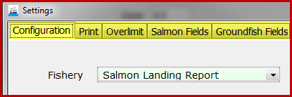
The first tab, Configuration, allows you to choose the fishery, salmon or groundfish, the toolbar color displayed at the top of tLandings, and a warning if total tare is missing. Total tare is used in Bristol Bay fisheries only. The Print tab allows you manage fish ticket copies, labels and the use of the signature pad. The Overlimit tab lets you set the species and limit threshold, as needed. The last two tabs, Salmon Fields/Groundfish Fields allow the customization of tLandings’ display.

We have added this ability to customize the display of fields to simplify data entry. The default tLandings version displays all data entry fields, whether they are pertinent to your reporting needs, or not. This can be confusing to tender operators to see fields that they may want to ignore. As an example, Date Fishing Ended is used only with salmon troll fishery. You now have the ability to hide fields that are not required for used for a specific fishery or for your seafood company. Landing Characteristics and temperature information have been requested by industry and are not required by ADF&G. Customized settings are managed within the PTI, during the thumb drive configuration process. Once these settings have been established, they persist until changed. In other words, all thumb drives will be configured with these settings until settings are changed.

Below is a display of the setting screen for salmon and groundfish. Again, note that we have changed the display of the settings menu this year to individual tabs.

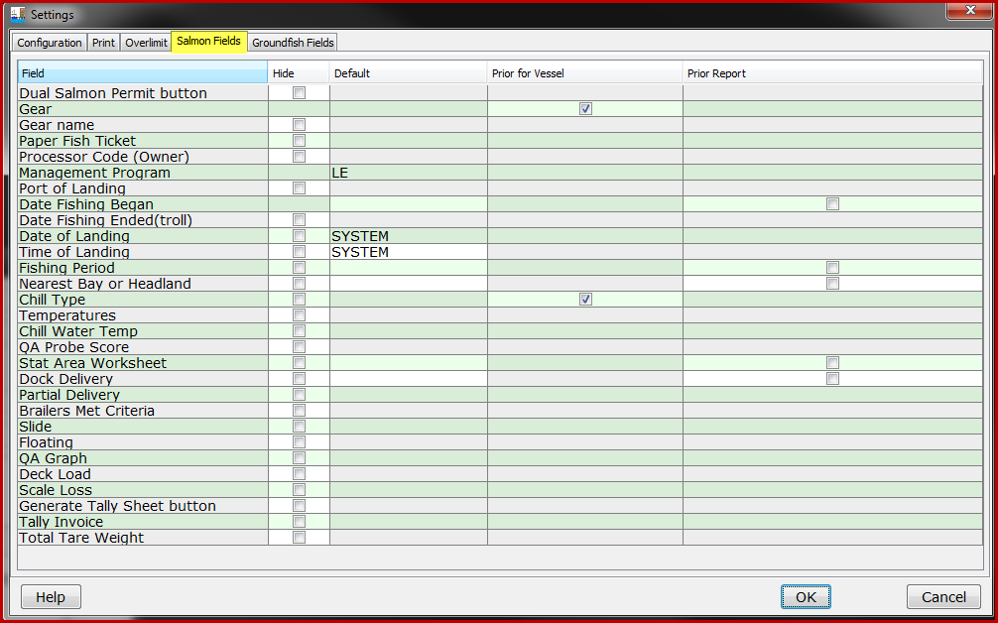
Salmon Customize Settings Window
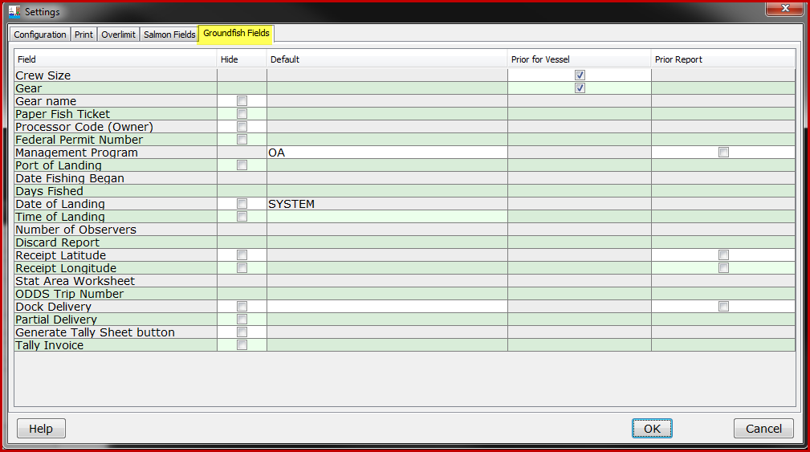
Groundfish Customize Settings Window
Salmon Fields
The salmon and groundfish setting tables list the Fields that can be hidden or defaulted. The column Hide provides check boxes to hide display of specific fields. The column Default lists the system defaults, such as Date and Time of Landing. If you type a value into default column for a field, such as Nearest Bay or Headland, that value will default for all fish tickets created from the thumb drive. The fourth column, Prior for Vessel, allows you to set two fields to default gear and chill type from the vessel’s prior landing reports contained on the thumb drive. The check “on” is the default. The last column, Prior Report, functions as the default function from prior versions of tLandings. Once clicked “on”, the tender operator enters the value on the first landing report and it persists until changed for all landings for the thumb drive.

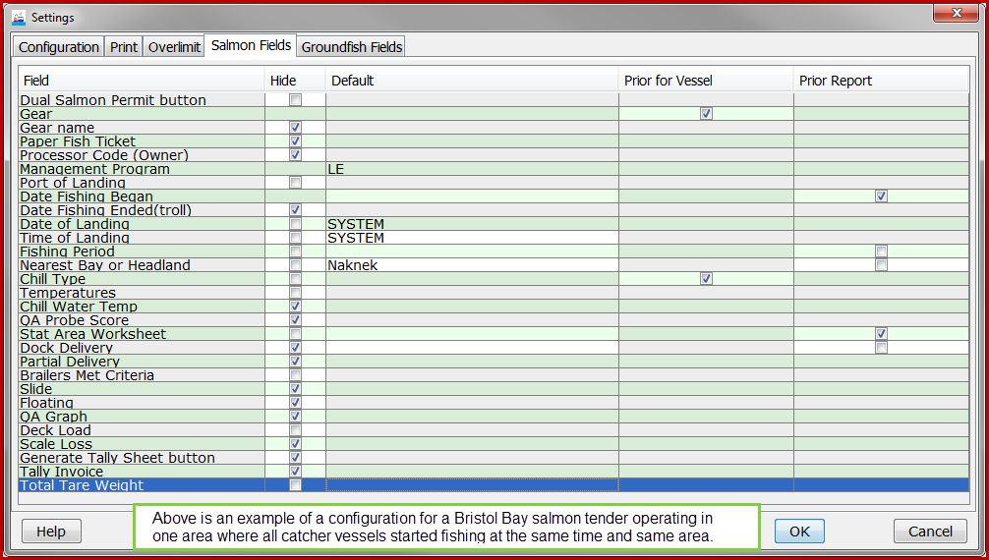
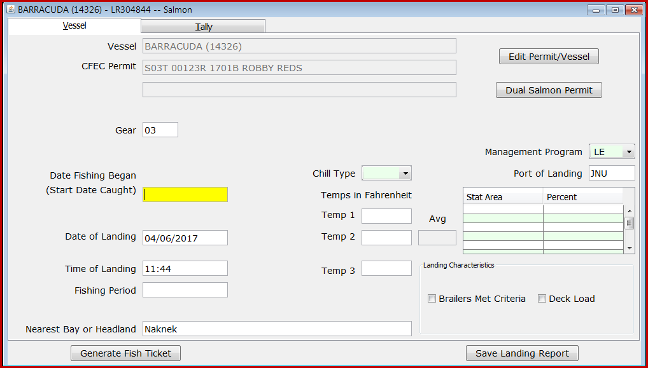

The tLandings for groundfish can also be customized.

The settings menu is available in the PTI, during thumb drive configuration and in tLandings from the Configuration menu.
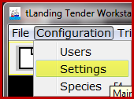

The best approach to understanding customized settings functioning is to change the display of fields and defaults in tLandings. Configure a thumb drive with no hidden or defaulted fields. Open tLandings and open a landing report to review the standard application. Close the report and choose Configuration/Settings/Salmon Fields. Review the fields and hide those that are not needed for a specific fishery. Clikc OK and then open a new landing report. Review and then repeat the process hiding other fields or setting up defaults. This process will help you understand now the new settings can be used. Remember, these are options and you may choose to hide no fields and use no defaults. The choice is yours.

NOTE: Nearest Bay or Headland, Date fishing Began, and Fishing Period can only be hidden if the tLandings salmon application is being used for Set Net sites. Receipt Latitude and Receipt Longitude can only be hidden if the thumb drive is being configured for a plant dock or buying station. You will receive an error message if you attempt to hide these fields when the thumb drive(s) is being configured for a tender.

When the custom configuration is completed a summary of your selections is provided prior to installation. In the example below note that the fishery is salmon and the hidden fields and defaluts are listed.
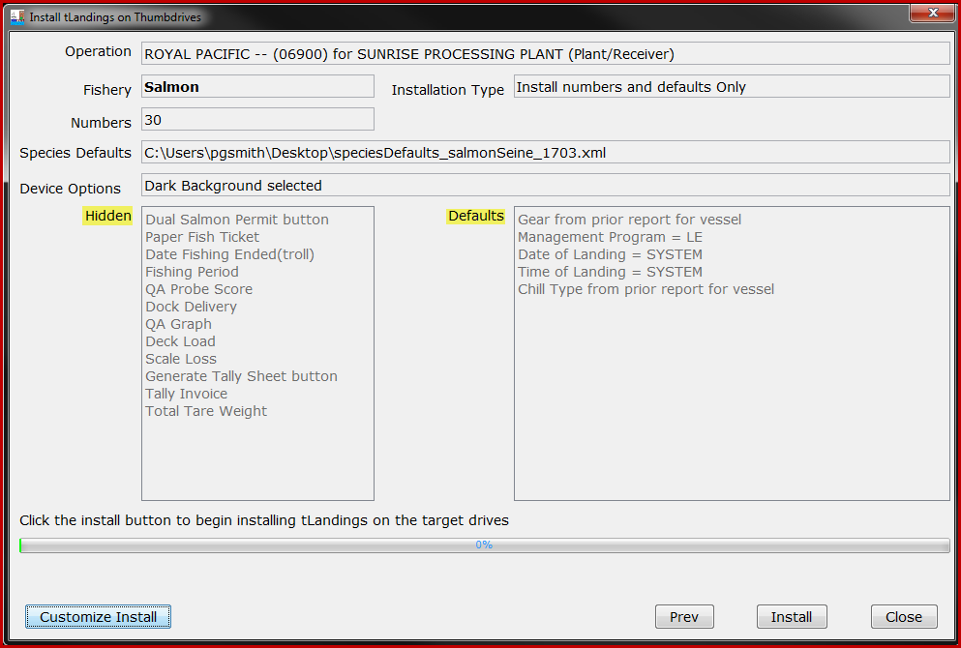
Configuration summary

The configuration and setting selections are displayed by clicking on Customized Install, Edit Configuration and Settings.

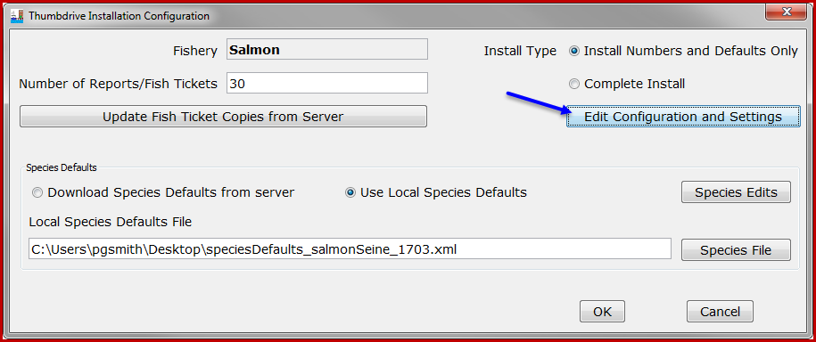

Tender Operations Management
Your eLandings operation(s) are listed from the dropdown menu. All operations associated with your eLandings user account are listed; plant receivers, buying stations and at sea operations.
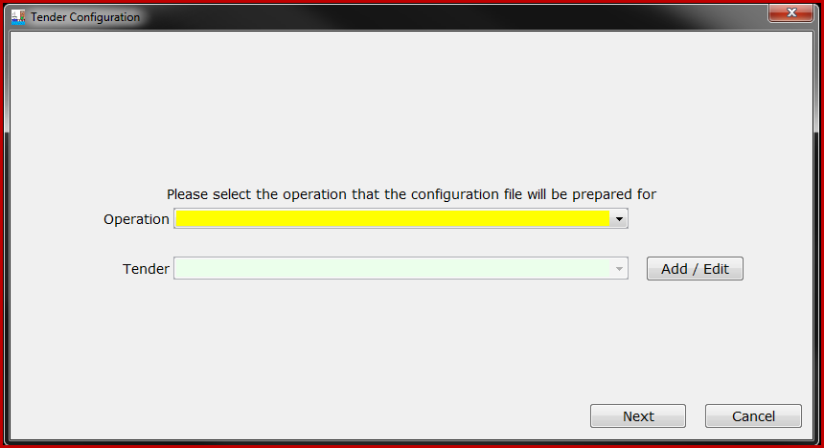
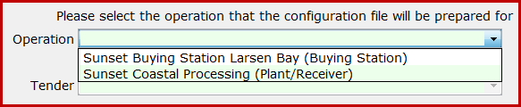
Depending on the structure and complexity of your seafood company, the Operation dropdown list may be short and simple, or contain several options.
Once you have selected the operation, the tenders associated with the eLandings Operation will be listed.
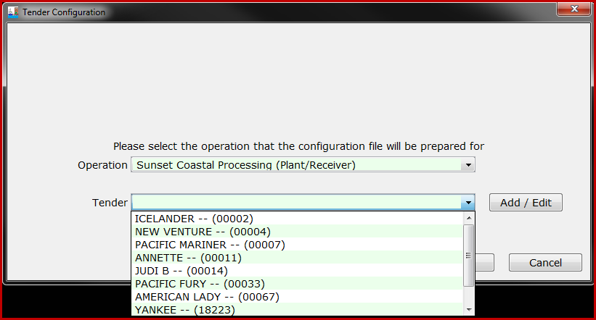
Select the tender you wish to prepare thumb drives for and then click the Next button. If the tender needing thumb drives is not listed, simply click on the Add/Edit button.
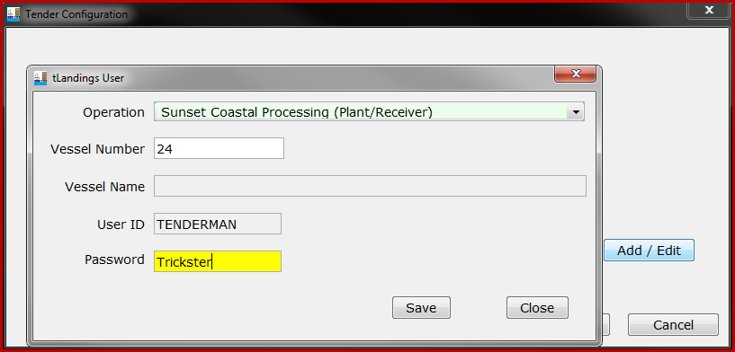
You can easily add a new tender by entering just the Vessel ADF&G license number and the password the tender operator will use to login to the thumb drive.
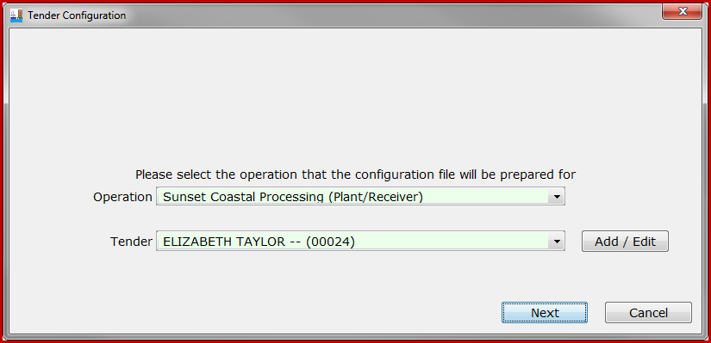
The tender vessel name is looked up from the eLandings database. When you add a tender, it will be a child operation for the parent plant/receiver. In the example above, the vessel Elizabeth Taylor, ADF&G # 24 was added and the password for the tender operator is Trickster. You no longer need to establish tender operations in the eLandings web application. Buying stations will continue to be established and managed from the eLandings web application, Administer Operations. When you add a tender operation, all Administrative and Normal users are added as authorized users for this child operation.
From this dialog box you can also change the tender operator’s password or delete the tender operation.
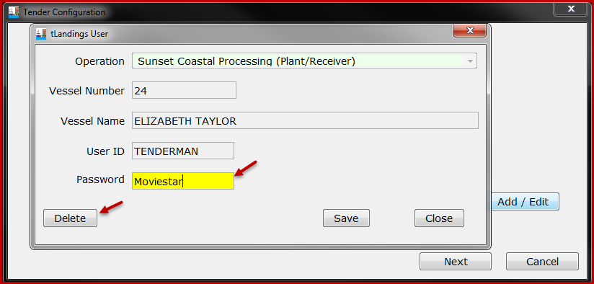
NOTE: We recommend setting up the tender operations and passwords as the first step, prior to any thumb drive configuration. This will simplify in-season use of the reporting system. All tenders for groundfish and salmon can be established with the Add/Edit feature. You can establish the tender operator’s password from the PTI Advanced Menu > Manage tLandings User Passwords.
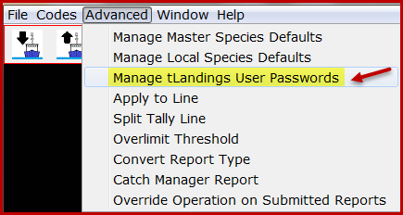
NOTE: If you are configuring thumb drives for a buying station, just choose the buying station and begin the configuration process.
The next dialog box is identical to previous versions of the PTI.
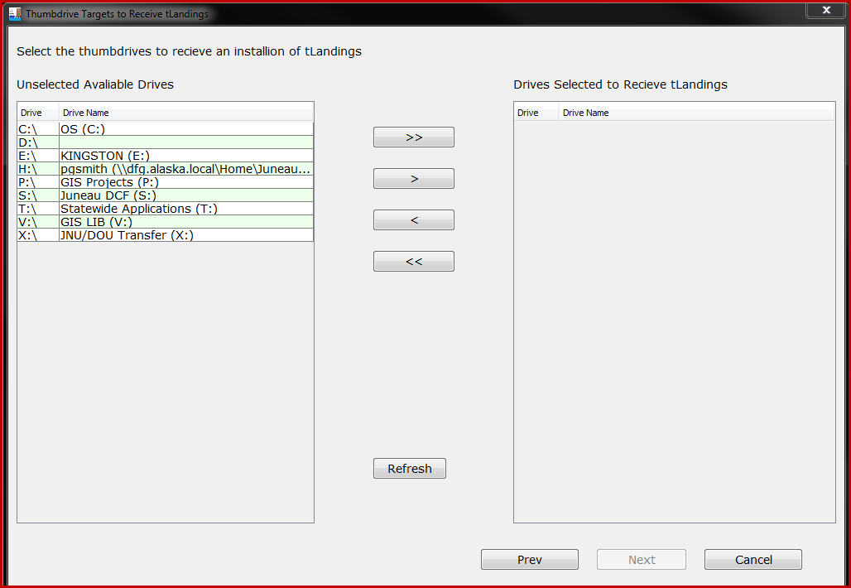
Identify the target thumb drive(s) for preparation and then click the next button. The dialog box below appears. Please note that the default application preparation for tLandings is SALMON. If you wish to configure a thumb drive for GROUNDFISH you will need to make that selection in the Settings. The tLandings application is used much more frequently for salmon, justifying this default.
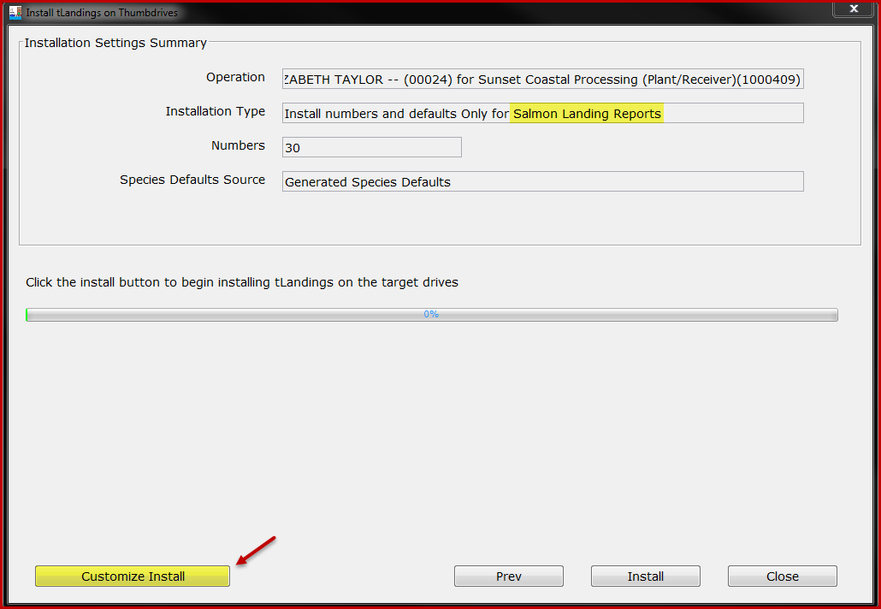
To prepare the thumb drives for groundfish landings, just click on the Customize Install button.
A new dialog box will appear and allow you to select the appropriate fishery – groundfish.
You can also select the species list saved locally on your workstation and modify the number of fish ticket numbers available on each thumb drive.
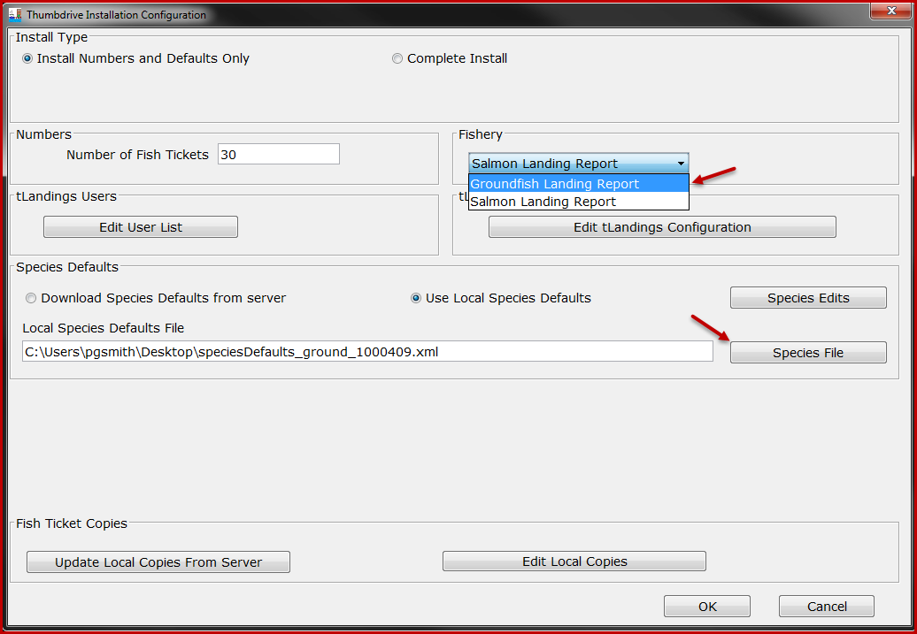
Once you have made the appropriate selections, click the OK button and you are ready to install the tLandings appropriate to the fishery, salmon or groundfish. Click the Install button.
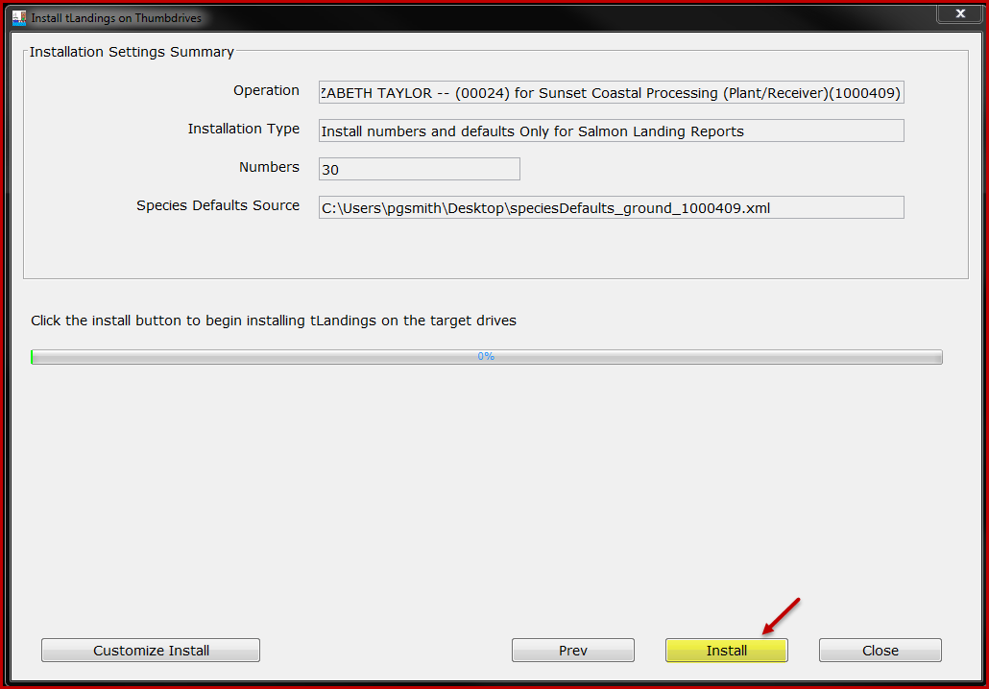
Additional Groundfish Data Elements
The vessel data entry page for tLandings configured for groundfish has been modified to include newly required fields. These fields are highlighted below in yellow.

The disposition of the Discard Report needs to be documented. The selections are: 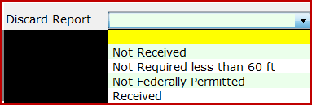
If an observer is aboard the catcher vessel, the tender operator needs to obtain from the observer the ODDS number. If no observer is aboard, list the number of observers as “0” and leave the ODDS Trip Number blank.
The location of the tender vessel operator must be documented at the time of each catcher vessel delivery. Latitude and longitude input formats are accessible from the tLandings link in blue text, Coordinate Formats.
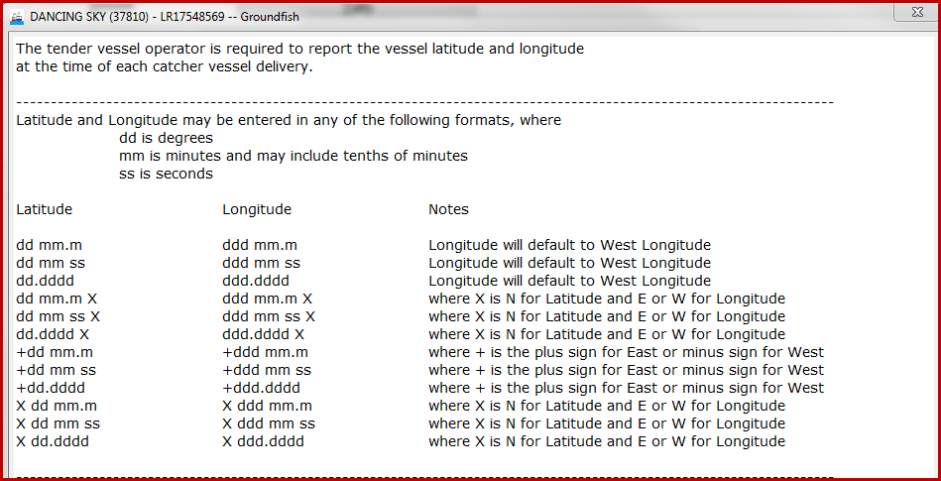
Please note the Management Program field just above the Stat Area Worksheet and Port fields. The Management Program ID remains static with salmon fisheries, LE – Limited Entry. This field is much more complex for groundfish fisheries.
Please check with the local office of ADF&G or NMFS to determine the management progrm for the tendered fishery, if in question. Below are the tLandings management program selections.
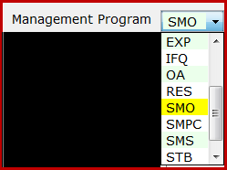
From the tLandings CODES menu, you can obtain a full list of all management program selections.
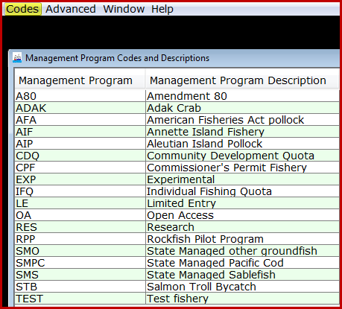
National Marine Fisheries Service is requiring tender vessel operators provide the landing information housed on the tLandings thumb drive to the seafood processing facility immediately upon docking and upload the eLandings database via the PTI by 1200 hours Alaska Standard Time, of the day following completion of the delivery. It is understood that the initial landing reports uploaded from the thumb drive are estimated weights. On the third day following the completion of the tender delivery, all landing reports must be finalized using the eLandings web application, no later than 1200 hours Alaska Standard Time.
The signed copies of the fish tickets must be submitted to the local office of ADF&G is seven days from the completion of the tender off-load.
New tLandings reporting Platforms
ADF&G is currently working with several seafood processors to migrate the tLandings application to a tablet platform. We are in the beginning stages of this process, conducting limited field trials. You might have noticed on the Configuration page, the selections for onscreen keyboard and black background color scheme, and the reference to the receipt printer on the Print page.
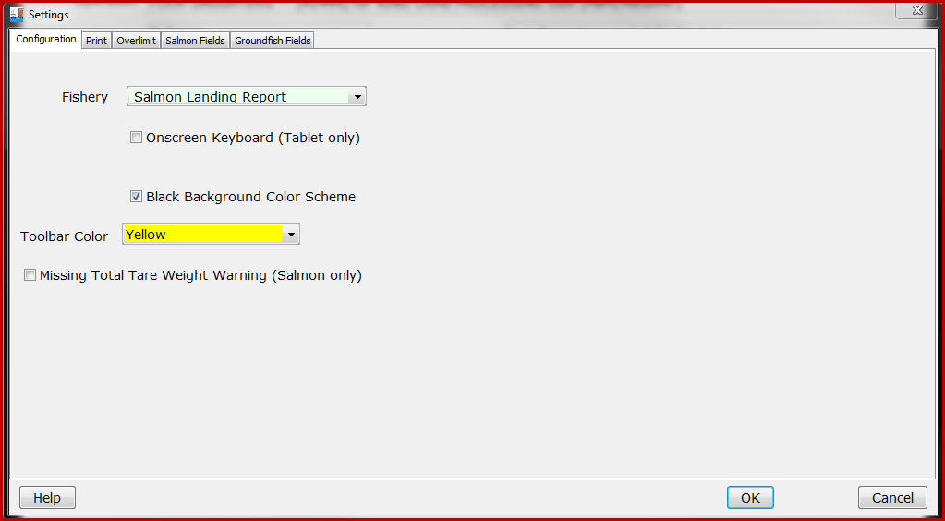
These selections are present to facilitate configuration of tablets. The black background color scheme assists in the reduction of screen glare. Below is a display of the white and black background.
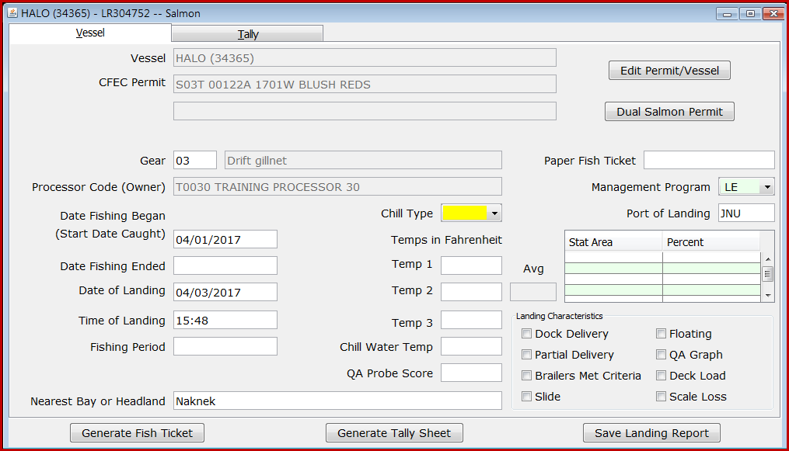
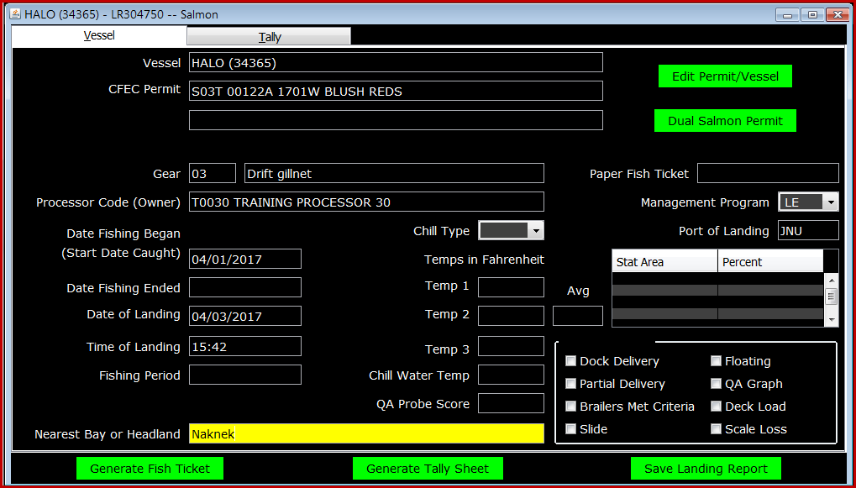
Some tender operators may find this display easier to read. It is a selection available for all machines; tablets, laptops and workstations.
We will keep you posted on our efforts to migrate tLandings to a tablet platform. We believe that the tablet platform will facilitate electronic reporting from beach based locations as well as small vessels.
If you need any help at all with the installation of the PTI or configuration/preparation of the thumb drives, please do not hesitate to contact Gail Smith at: gail.smith@alaska.gov or elandings@alaska.gov. We make every effort to respond quickly.

