2018 PTI and tLandings for Salmon and Groundfish User Documentation
The 2018 Processor Tender Interface (PTI) application, used to configure thumb drives for groundfish and salmon is now available for download from this link. We recommend that you print this document, as it provides detailed information and application screen images. This is a full summary of the changes we have made to the PTI and tLandings recently. Please read carefully and retain as a resource.
The PTI prepares thumb drives for tenders and buying stations, loading the tLandings application with your business permits and license codes. Each year, you will need to refresh the PTI to obtain the most recent updates and improvements to both the PTI and tLandings. As the tLandings application has also changed, you will need to make certain that all thumb drives used with the tLandings application have had all files deleted. In other words, all thumb drives should be empty.
You will need to download the 2018 PTI for groundfish to prepare tenders for landings in 2018. Please download the newest PTI Release 6.5 Build 224 at any time prior to your need for configured thumb drives. The link to the instructions and the application installation is linked above. We are continuing to develop the PTI/tLandings with a few additional enhancements for salmon tendering. In April, we will contact all eLandings PTI users with instructions to refresh the PTI version. The additional changes to both the PTI and tLandings and they are only available when you download the newest version. The PTI icon will remain identical but will link to the latest version of the PTI.
As mentioned, the desktop icon will remain the same when you download the latest version of the PTI. What will change is the release and build numbers which are displayed when you first log into the application. Please check to make certain you have the currently recommended version.
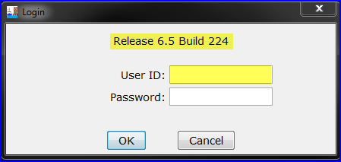
The login dialog box will include the Release and Build number. Please check prior to use.

This action will assure that tickets generated in the tLandings application are identified with the E18 unique number identifier.
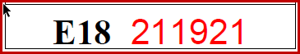
The PTI and tLandings changed in 2017 in five major ways, summarized below:
- CFEC PERMIT AND VESSEL DATA CAPTURE - Both CFEC permit and vessel information is now captured when you complete a successful swipe of the permit.
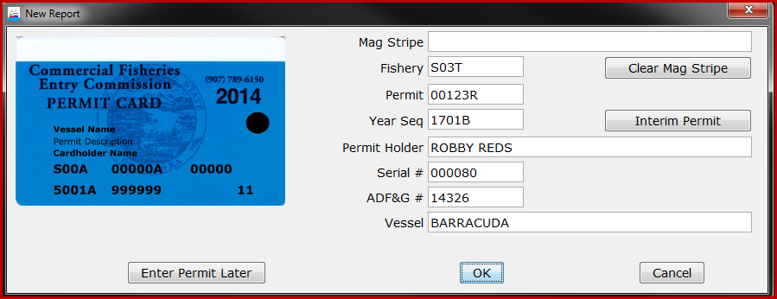
- Vessel Lists and Vessel Pick Lists - Because the application now harvests the vessel information from the CFEC permit card, you no longer need to develop and manage a vessel list(s). Tender operators will need to make certain that the vessel information listed on the permit card and stored on the magstripe is correct, as vessels can change once the season begins.
- Setting and Customized Display - The tLandings application was designed to provide a reporting tool for all salmon or groundfish fisheries. This has meant that the application has data entry fields that do not pertain to regional fishery requirements. To simplify reporting and unclutter the tLandings application entry screens, we are now providing the option to customize the display of fields on the vessel tab. Below are illustrations of the non-customized and customized data entry screens.

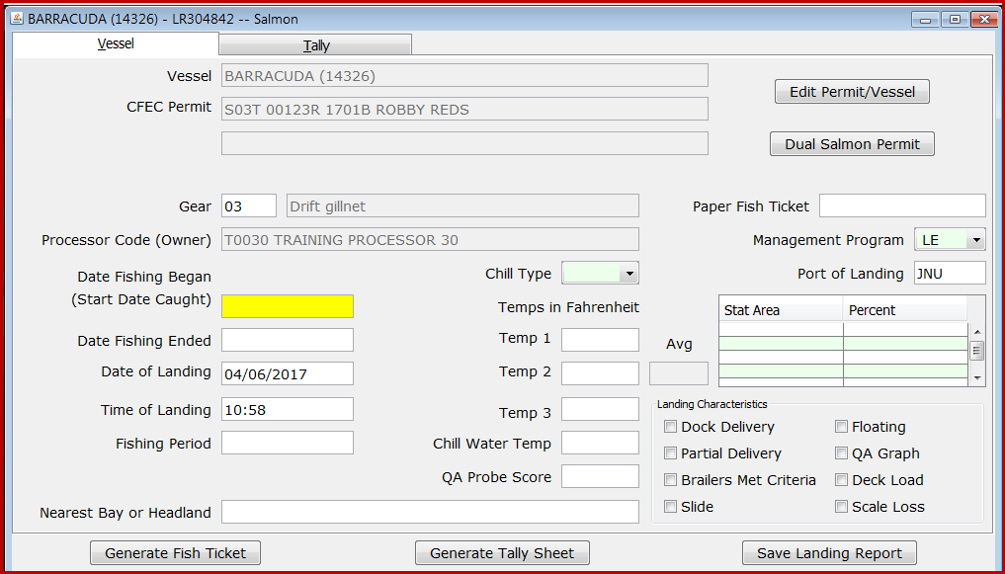
Standard Display
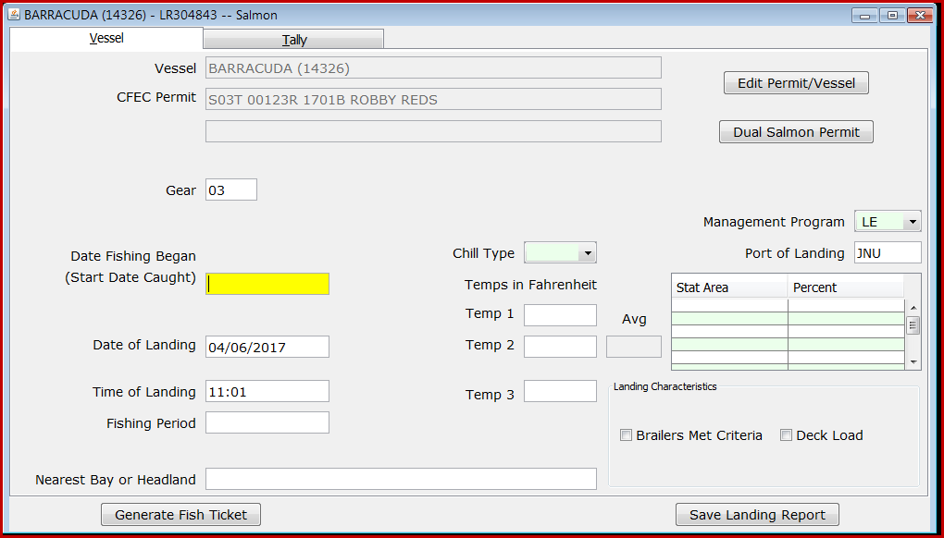
Customized Display

- Tender Operations Management - We have also simplified the establishment of tender operations and the selection of tenders within the PTI.
When you initiate preparing the thumb drive(s) for the tender, select the down arrow located in the upper left hand corner.
A dialog box appears allowing you to choose your operation and the tender.
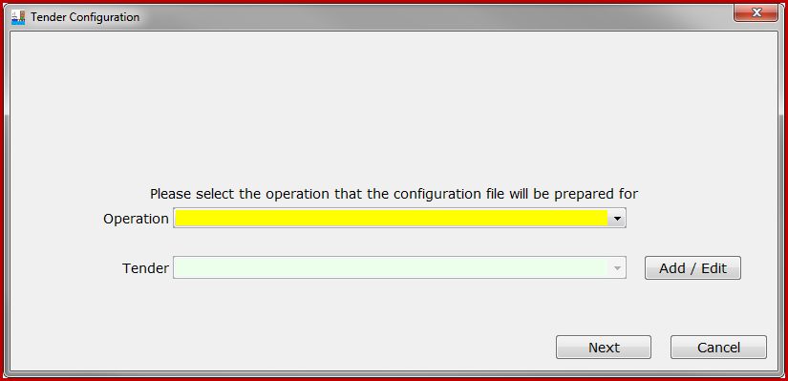
Note the Add/Edit button next to the Tender selection, which allows you to add additional tender operations.
- Additional Groundfish Data Elements - tLandings for groundfish has been modified to requiring documentation of the new data elements.

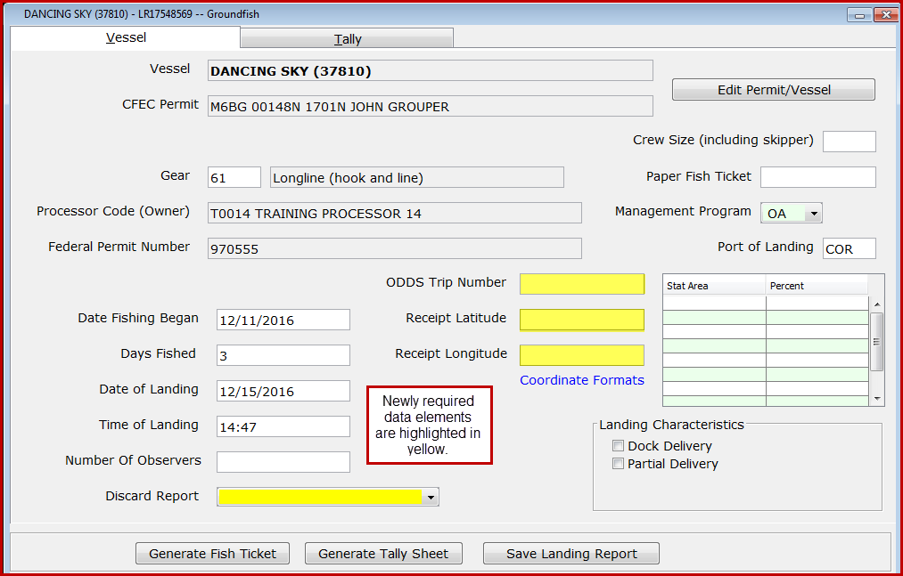

Changes to eLandings, the PTI AND tlandings for 2018
The eLandings team built upon the changes made last year and added additional enhancements.
- Setting and Customized Display EXPANDED TO THE TALLY PAGE
Last year we implemented the ability to customize the display of data entry fields within the PTI. Configuration of landings settings was modified to a dialog box with several tabbed screens.
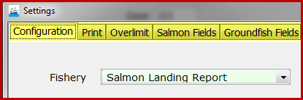
2017 PTI Settings Configuration
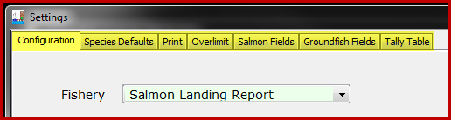
2018 PTI Settings Configuration
Note that two additional tabs have been added, Species Defaults and Tally Table.

- CONFIGURATION PROFILES
Each processor can now establish and store several configuration types, depending on the activity of the tender and your fisheries. These configuration types can now be stored and selected as configuration profiles.
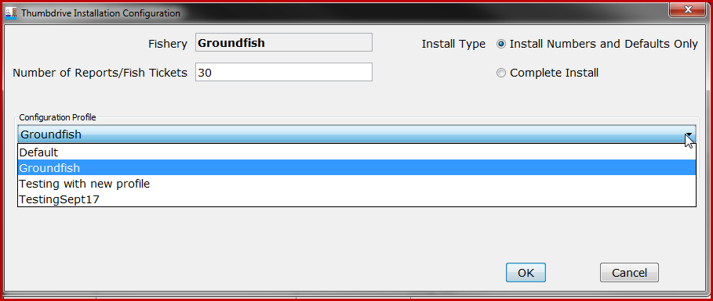
Configuration profiles used with PTI Test, for testing purposes

You can also manage these profiles, adding a new profile, editing a profile or deleting a profile.
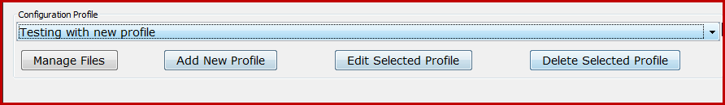

Each configuration profile is displayed on the Install page of the PTI for review. Not that all hidden fields, those fields that will not be displayed on the tLandings application pages, are listed, as well as established default values.
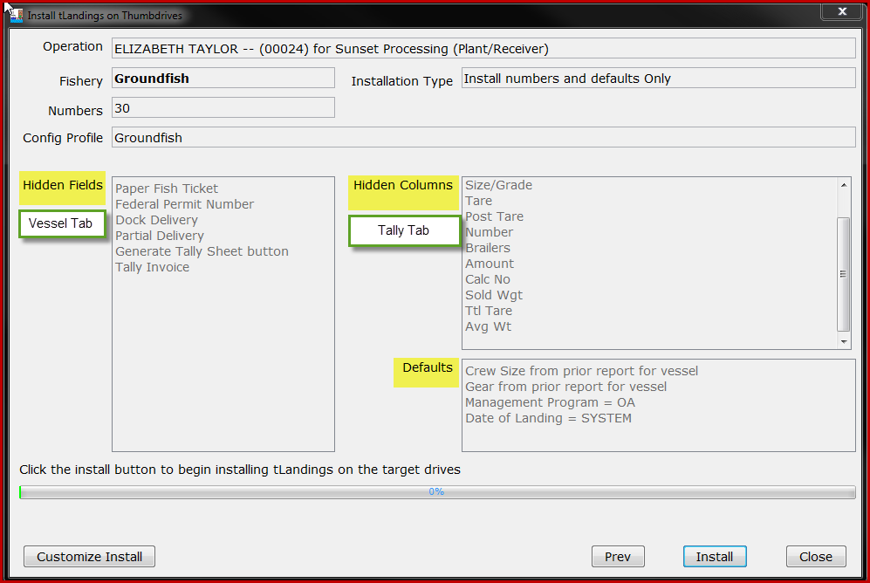

In addition to hidden fields and columns, and default values, each configuration profile can store and load customized species lists that may or may not include grading and pricing information.

In addition to these enhancements of the features we introduced in 2017, we have added the ability to configure thumb drives for a new reporting platform, tablets.

- eTABLET CONFIGURATION
The tablet platform for tLandings was designed to support electronic reporting from beach-based fisheries, specifically set net sites. Signatures are captured on the tablet and then printed on a wireless mobile printer. Specific setting, such as an onscreen keyboard and a black background with white text to reduce glare are available for selection.
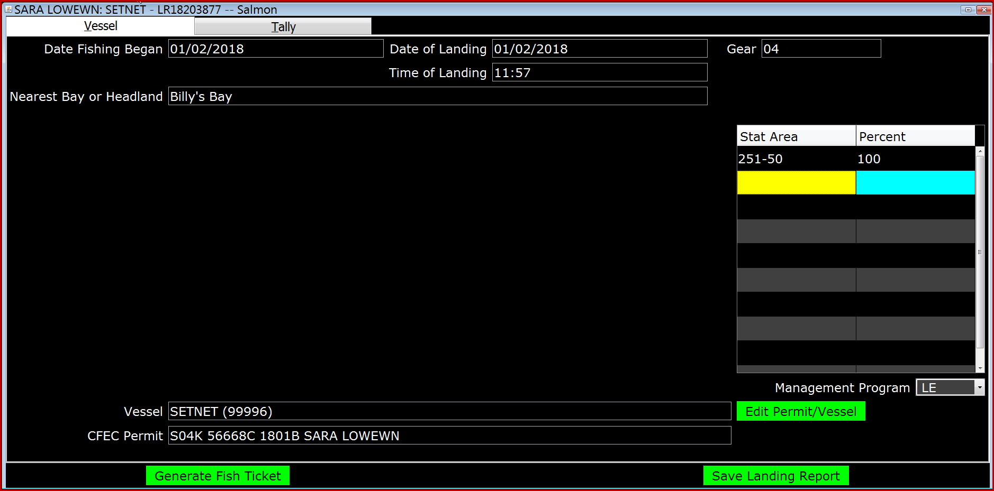
The example above is the black background tablet display with many unneeded fields hidden.

Both the fisher and the agent for the processor sign on the tablet. The signatures are printed on the fish ticket copies.

- AVERAGE WEIGHTS REPORT BY TENDER DELIVERY AND SPECIES
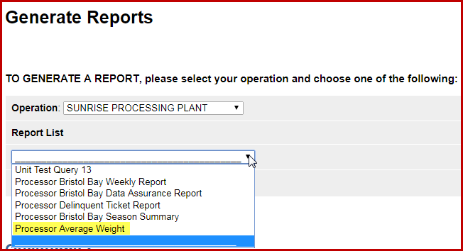
Processor staffs can now monitor the reported average weight of each salmon species by tender offload using the report available within eLandings Generate Reports Menu. The report will be emailed to you within a few minutes of your request.
This report will provide you with a tool to monitor outlier average weights by individual species that are potentially too low or too high.
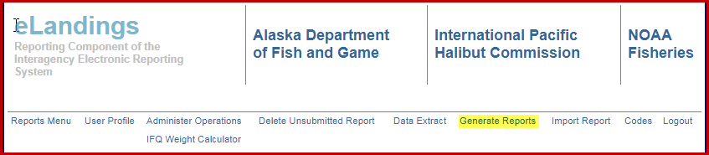

Settings and Customized Display

Configuration of tLandings settings has been modified to a dialog box with several tabbed screens.
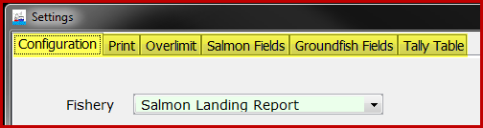

The first tab, Configuration, allows you to choose the fishery - salmon or groundfish, the toolbar color displayed at the top of tLandings, and a warning if total tare is missing. Total tare is used in Bristol Bay fisheries only. The Onscreen Keyboard is used only with tablet platforms. The starting font size for a laptop is 14 and the starting font size for a tablet is 26, as display screen size changes with the machine.

The black background color scheme is very helpful with the tablet and can be selected by the individual tender operator, as an optional display.
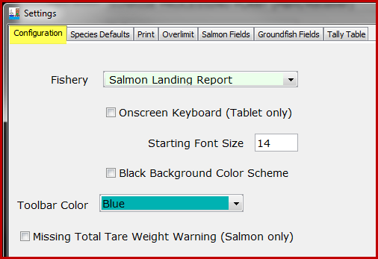

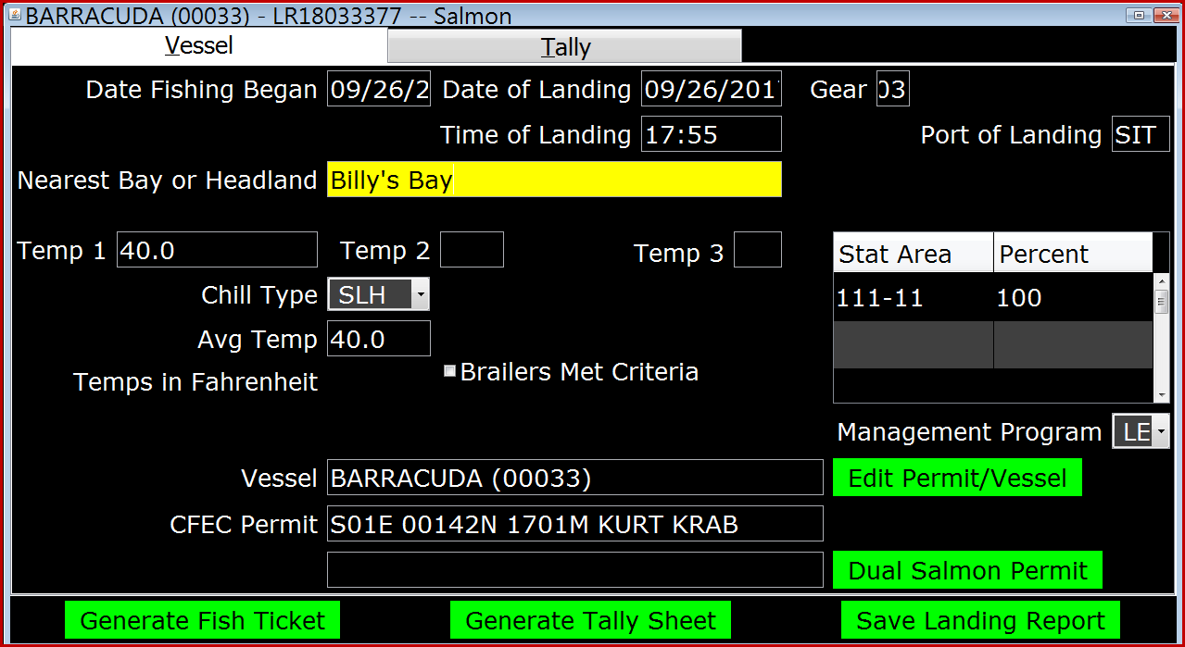
Black background color scheme
The next tab is the Species Defaults. The “default” for the PTI is to obtain the species list from the server. Your office staff may not have a specific species list saved to the eLandings server or it may most list groundfish IFQ. The enhancement we made this year is to allow you to create and store multiple species lists, for groundfish and for specific salmon fisheries.

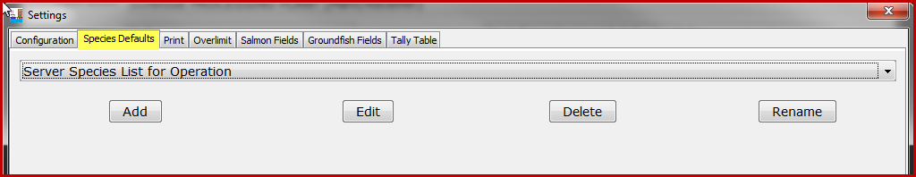

If you click on the Add button a new dialog box will appear.

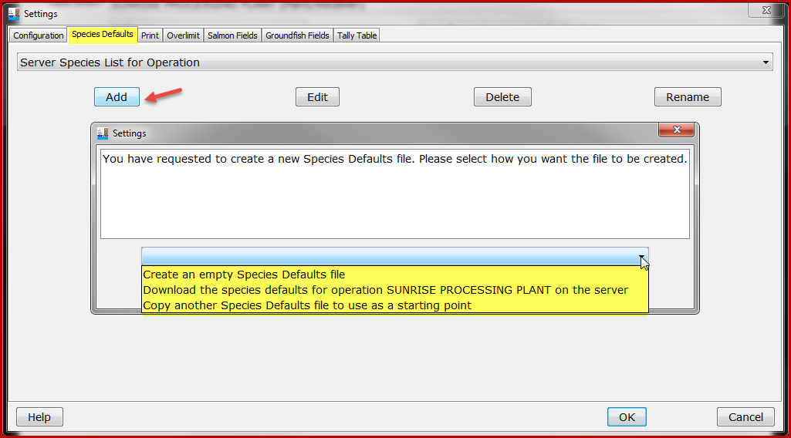

Start simple and create a Species Default file from an empty table. You will be prompted to name the Species Default file first.

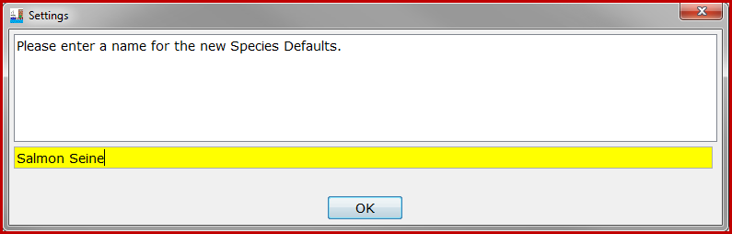
Provide a name for the species table.

When you click OK an empty Species Default table will open and you can add species (salmon or groundfish), delivery condition codes and grading/pricing (optional).
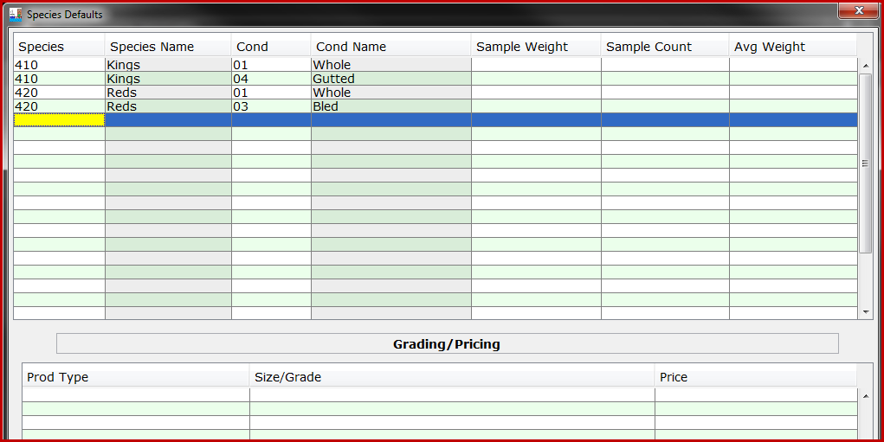
When you click on the save button, the species table will display as a possible selection. You can make as many Species Default tables as you need. These tables can also be edited, deleted and renamed.
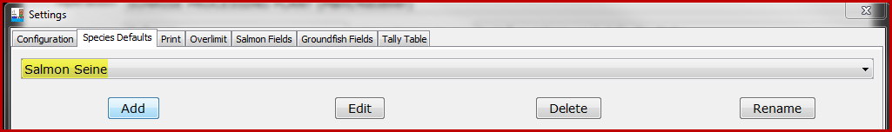

The Print tab allows you manage fish ticket copies, labels and the use of the signature pad. The Overlimit tab lets you set the species and limit threshold, as needed. The last two tabs, Salmon Fields/Groundfish Fields allow the customization of tLandings’ display.

We have added this ability to customize the display of fields in the vessel and tally tabs of tLandings to simplify data entry. The Salmon Fields and the Groundfish Fields display all selections in the Vessel Tab of tLandings. The default tLandings version displays all data entry fields, whether they are pertinent to your reporting needs, or not. This can be confusing to tender operators to see fields that they may want to ignore. As an example, Date Fishing Ended is used only with salmon troll fishery. You now have the ability to hide fields that are not required for used for a specific fishery or for your seafood company. Landing Characteristics and temperature information have been requested by industry and are not required by ADF&G. Customized settings are managed within the PTI, during the thumb drive configuration process. Once these settings have been established, they persist until changed. In other words, all thumb drives will be configured with these settings until settings are changed.

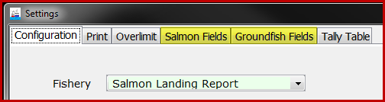

Below is a display of the setting screen for salmon and groundfish. Again, note that we have changed the display of the settings menu this year to individual tabs.

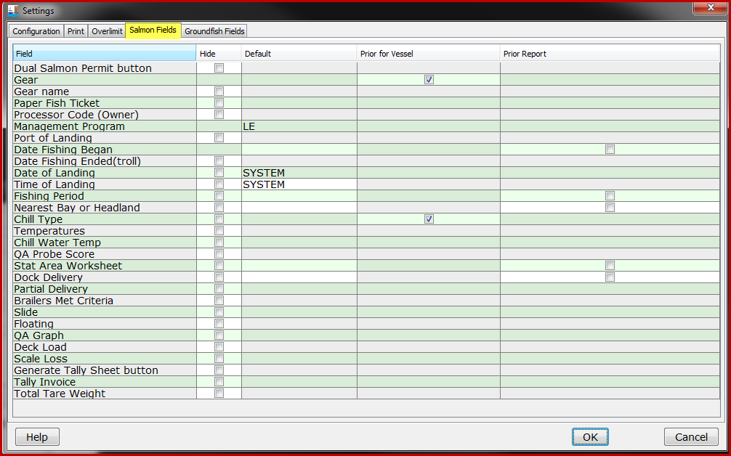
Salmon Customize Settings Window
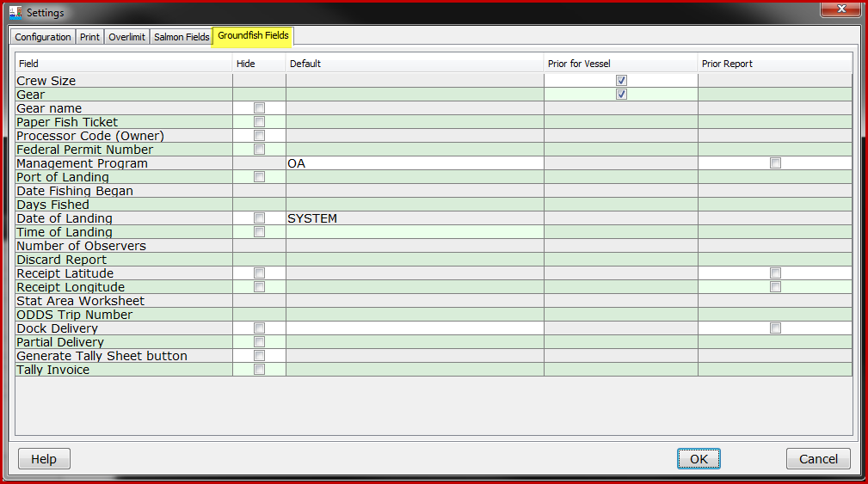
Groundfish Customize Settings Window

Salmon Fields

The salmon and groundfish setting tables list the Fields that can be hidden or defaulted. The column Hide provides check boxes to hide display of specific fields. The column Default lists the system defaults, such as Date and Time of Landing. If you type a value into default column for a field, such as Nearest Bay or Headland, that value will default for all fish tickets created from the thumb drive. The fourth column, Prior for Vessel, allows you to set two fields to default gear and chill type from the vessel’s prior landing reports contained on the thumb drive. The check “on” is the default. The last column, Prior Report, functions as the default function from prior versions of tLandings. Once clicked “on”, the tender operator enters the value on the first landing report and it persists until changed for all landings for the thumb drive.

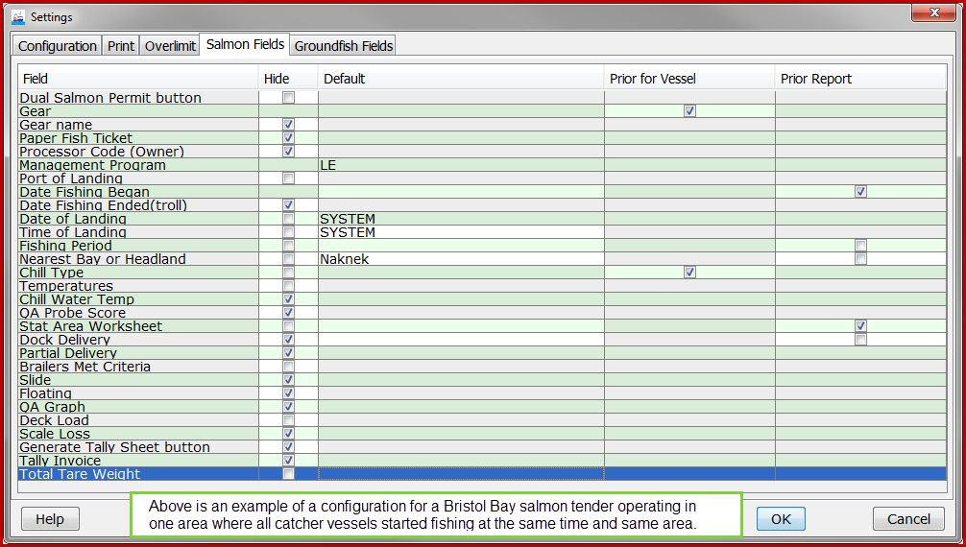
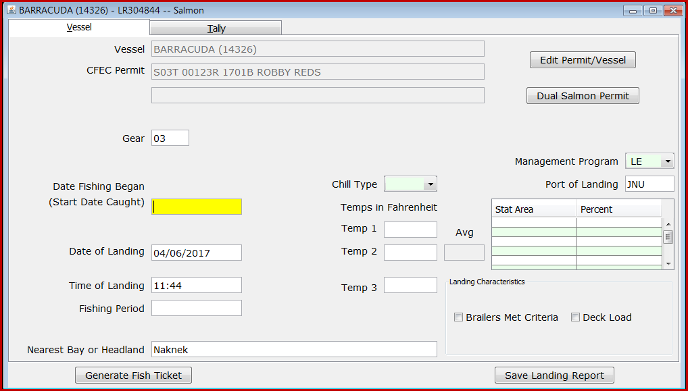

The tLandings for groundfish can also be customized.

The Tally Table tab can be used with either salmon or groundfish. The selections below are for salmon landings to tenders that do not price or grade the product they land. Note that Disposition code is not listed. This field must be present for all landings to record personal use or product retained for another purpose. The default value is 60 (Sold) but it can be change to any other appropriate code.

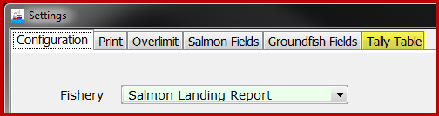
The Tally Table
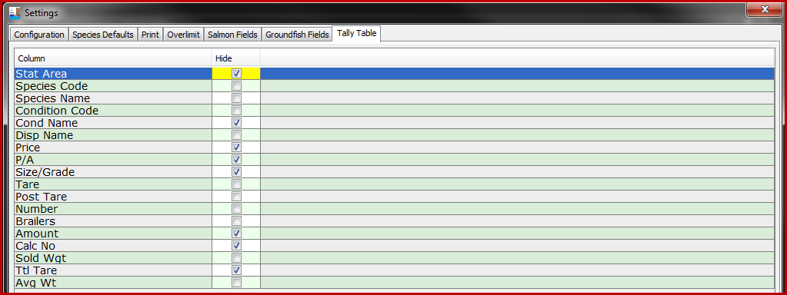

The Configuration menu selection is no longer available in the PTI, but is available in the tLandings application. If you do not want your tender operators to modify the settings, please instruct them to not change settings. We do not want to lock down the ability for the tender operator to modify a setting in the event the configuration was incorrect for their fishery or you hid a field they need to use.
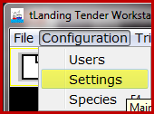
tLandings Configuration

Once you have completed the configuration profile, please take a moment to review your selections. If correct, you can click Install and configure one or more thumb drives.

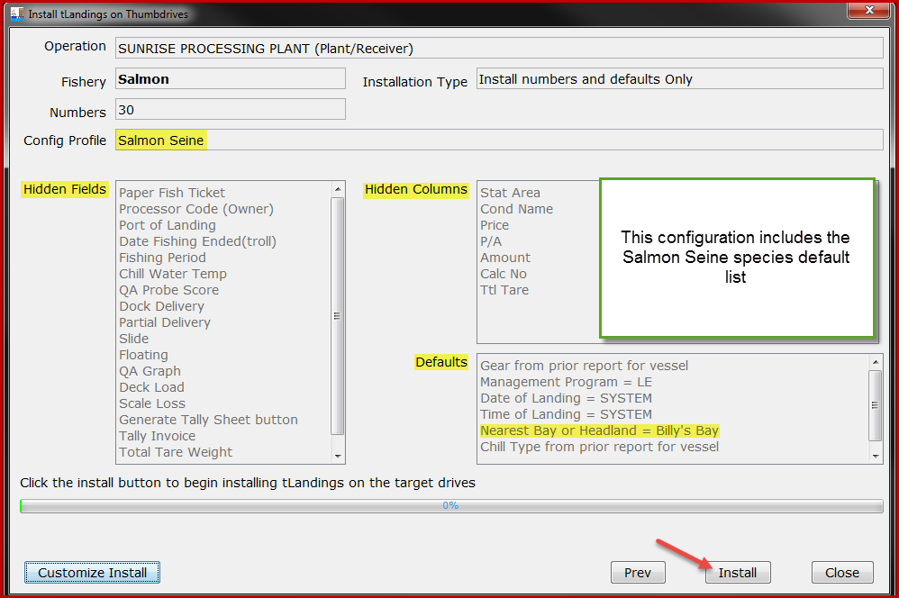
Configuration summary

The best approach to understanding customized settings functioning is to change the display of fields and defaults in tLandings. Configure a thumb drive with no hidden or defaulted fields. Open tLandings and open a landing report to review the standard application. Close the report and choose Configuration/Settings/Salmon Fields. Review the fields and hide those that are not needed for a specific fishery. Clikc OK and then open a new landing report. Review and then repeat the process hiding other fields or setting up defaults. This process will help you understand now the new settings can be used. Remember, these are options and you may choose to hide no fields and use no defaults. The choice is yours.

NOTE: Nearest Bay or Headland, Date fishing Began, and Fishing Period can only be hidden if the tLandings salmon application is being used for Set Net sites. Receipt Latitude and Receipt Longitude can only be hidden if the thumb drive is being configured for a plant dock or buying station. You will receive an error message if you attempt to hide these fields when the thumb drive(s) is being configured for a tender.

The most recent Configuration Profile is the new default with you open the
PTI. If you want to use another Configuration Profile or create a new profile, The configuration and setting selections are displayed by clicking on Customized Install, Edit Configuration and Settings.

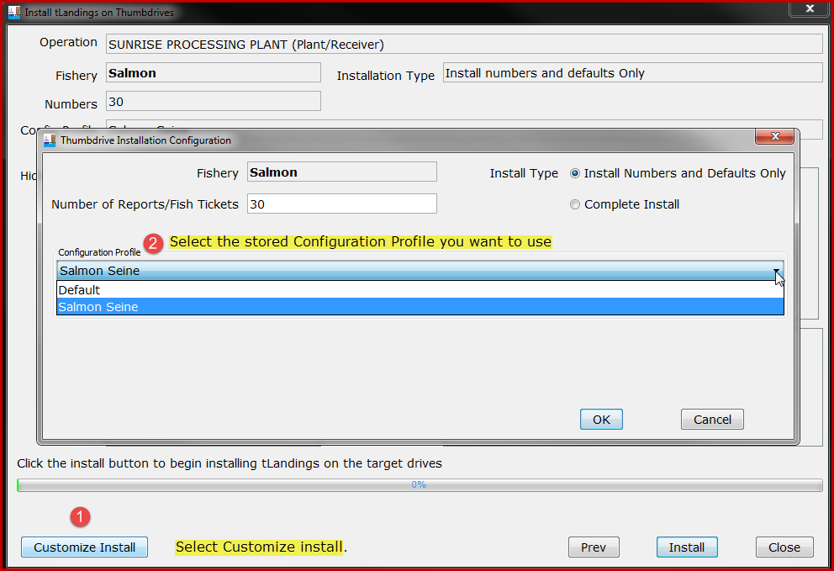

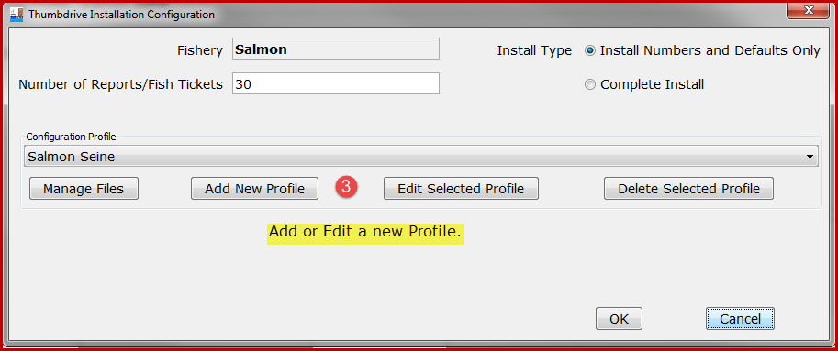

Tender Operations Management – Review of 2017 changes
Your eLandings operation(s) are listed from the dropdown menu. All operations associated with your eLandings user account are listed; plant receivers, buying stations and at sea operations.
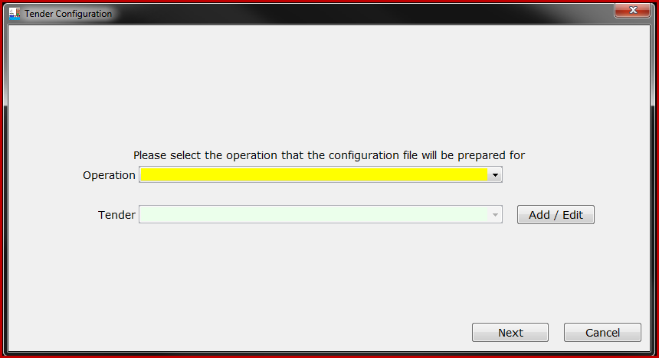
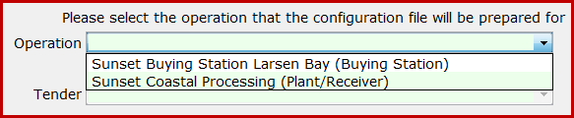
Depending on the structure and complexity of your seafood company, the Operation dropdown list may be short and simple, or contain several options.
Once you have selected the operation, the tenders associated with the eLandings Operation will be listed.
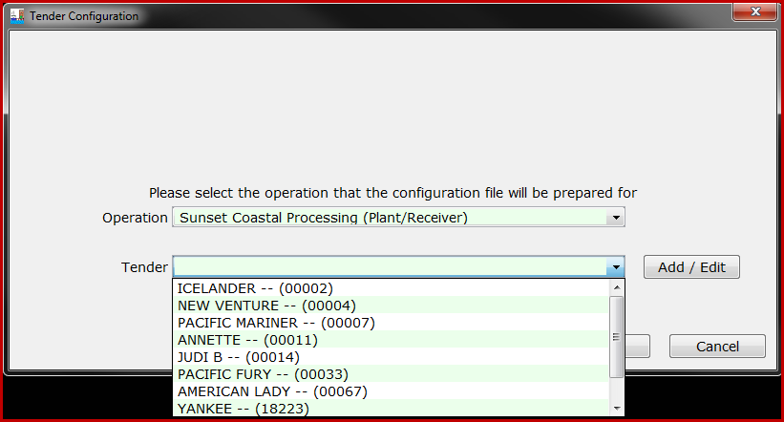
Select the tender you wish to prepare thumb drives for and then click the Next button. If the tender needing thumb drives is not listed, simply click on the Add/Edit button.
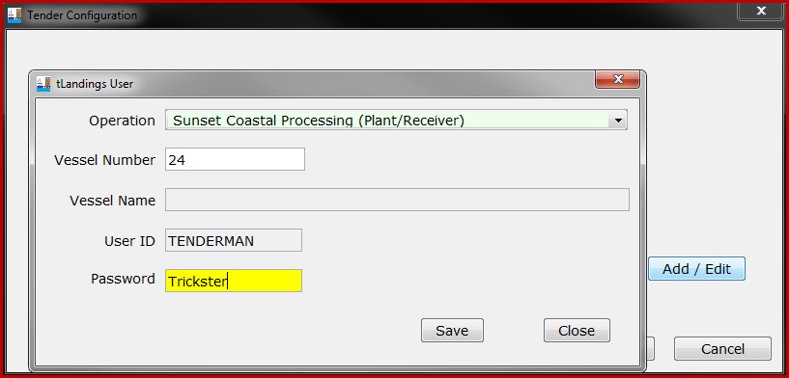
You can easily add a new tender by entering just the Vessel ADF&G license number and the password the tender operator will use to login to the thumb drive.
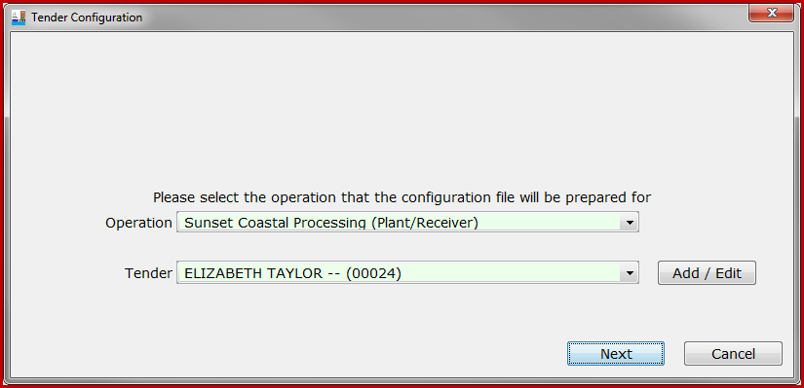
The tender vessel name is looked up from the eLandings database. When you add a tender, it will be a child operation for the parent plant/receiver. In the example above, the vessel Elizabeth Taylor, ADF&G # 24 was added and the password for the tender operator is Trickster. You no longer need to establish tender operations in the eLandings web application. Buying stations will continue to be established and managed from the eLandings web application, Administer Operations. When you add a tender operation, all Administrative and Normal users are added as authorized users for this child operation.
From this dialog box you can also change the tender operator’s password or delete the tender operation.
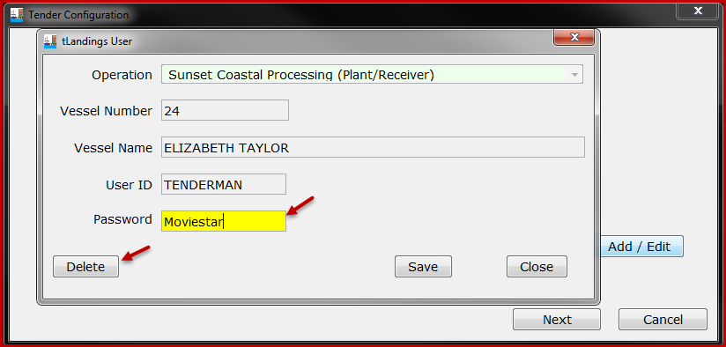
NOTE: We recommend setting up the tender operations and passwords as the first step, prior to any thumb drive configuration. This will simplify in-season use of the reporting system. All tenders for groundfish and salmon can be established with the Add/Edit feature. You can establish the tender operator’s password from the PTI Advanced Menu > Manage tLandings User Passwords.
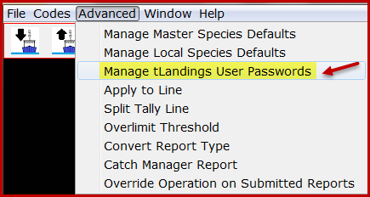
NOTE: If you are configuring thumb drives for a buying station, just choose the buying station and begin the configuration process.

To prepare the thumb drives for groundfish landings, just click on the Customize Install button.
A new dialog box will appear and allow you to select the appropriate fishery – groundfish.
You can also select the species list saved locally on your workstation and modify the number of fish ticket numbers available on each thumb drive.

Once you have made the appropriate selections, click the OK button and you are ready to install the tLandings appropriate to the fishery, salmon or groundfish. Click the Install button.

Additional Groundfish Data Elements
The vessel data entry page for tLandings configured for groundfish has been modified to include required fields. These fields are highlighted below in yellow.

The disposition of the Discard Report needs to be documented. The selections are: 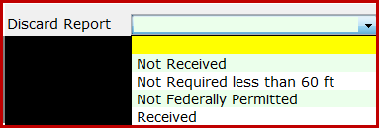
If an observer is aboard the catcher vessel, the tender operator needs to obtain from the observer the ODDS number. If no observer is aboard, list the number of observers as “0” and leave the ODDS Trip Number blank.
The location of the tender vessel operator must be documented at the time of each catcher vessel delivery. Latitude and longitude input formats are accessible from the tLandings link in blue text, Coordinate Formats.
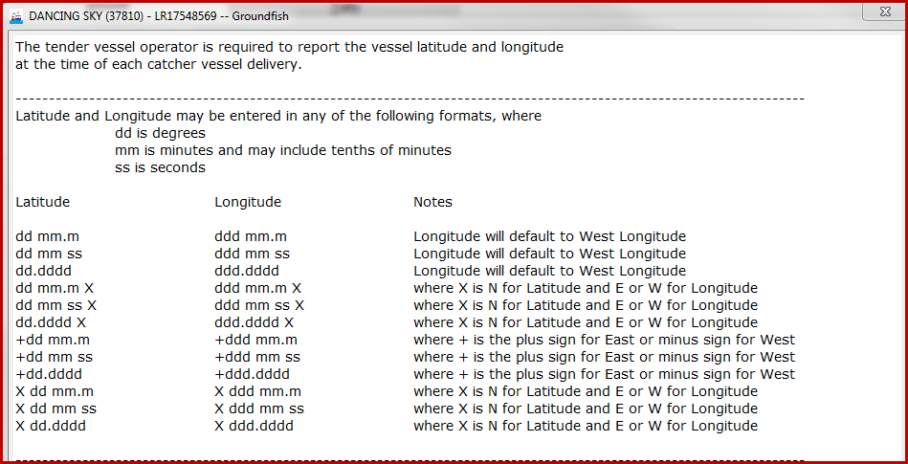
Please note the Management Program field just above the Stat Area Worksheet and Port fields. The Management Program ID remains static with salmon fisheries, LE – Limited Entry. This field is much more complex for groundfish fisheries.
Please check with the local office of ADF&G or NMFS to determine the management program for the tendered fishery, if in question. Below are the tLandings management program selections.
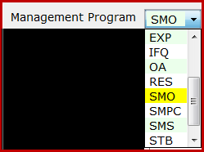
From the tLandings CODES menu, you can obtain a full list of all management program selections.
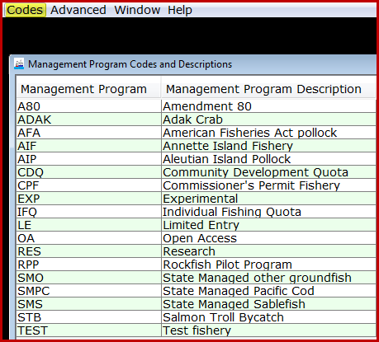
National Marine Fisheries Service is requiring tender vessel operators provide the landing information housed on the tLandings thumb drive to the seafood processing facility immediately upon docking and upload the eLandings database via the PTI by 1200 hours Alaska Standard Time, of the day following completion of the delivery. It is understood that the initial landing reports uploaded from the thumb drive are estimated weights. On the third day following the completion of the tender delivery, all landing reports must be finalized using the eLandings web application, no later than 1200 hours Alaska Standard Time.
The signed copies of the fish tickets must be submitted to the local office of ADF&G is seven days from the completion of the tender off-load.
New tLandings Tablet reporting Platform
Additional information on our new reporting tablet reporting platform will be available at the end of January 2018.

If you need any help at all with the installation of the PTI or configuration/preparation of the thumb drives, please do not hesitate to contact elandings@alaska.gov. We make every effort to respond quickly.

