Installing PTI on Windows 7 Machines

Installing PTI on a Windows 7 Operating System
If you are installing PTI on a computer workstation with Windows 7, we recommend you take the following steps to ensure a seamless installation. These instructions use the pti-4.69-10563-installer.zip file as the example, but the actual zip file you download and install may have newer release and build numbers, as new versions are deployed to resolved issues.
Like most software on Microsoft Windows, the PTI software needs to be installed with Administrator privileges. This means you need a userid that has Admin privileges. If you don’t have an IT Group administering your computers then that may be your normal userid. If you do have an IT Group, they will know whether or not your userid has Admin privileges, and may be able to provide you with a userid that has Admin privileges on your workstation, or may otherwise assist you in installing the software.

Step 1.

Create a new folder on your desktop. We recommend naming it PTI Installer <build#> where build# is the build number in the installer zip file name. For example, if the installer zip file is pti-4.69-10571-installer.zip the folder name would be PTI Installer 10571

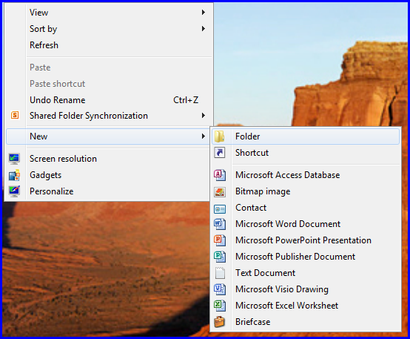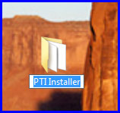

Step 2.
You can download the PTI installer from this link:

https://elandings.atlassian.net/wiki/display/tr/tLandings+PTI+Installer+Download+and+tLandings+2014+Salmon+Season+Preparations

From the web link above, locate the pti-4.xx-nnnnnn-installer.zip file (where xx is the release number and nnnnnn is the build number) and click on the link once.
You will see a small dialog box at the bottom of your screen, Do you want to open or save….Select SAVE.

The PTI installer will be downloaded from our website. When the download is complete, you can locate the zipped file in your download folder.

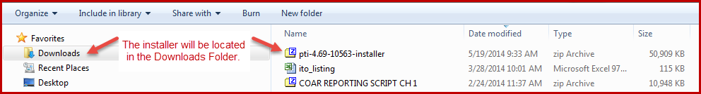

Step 3.
Create a new folder on your desktop. Name the folder “PTI nnnnnn” where nnnnnn is the build number for the zip file you downloaded. (In the picture above it is 10563, but it will actually be whatever is in the name of the zip file you downloaded.

Locate the zipped file in your downloads directory. Drag it to the new folder you created, or copy it and paste it in the new folder. In the new folder, right click on the zip file and locate the action, Extract all. This will extract the files to your PTI nnnnnn folder, located on your desktop.

Step 4.
Find the Install file in the files you just extracted from the zip file. It is a Window Batch File. It may be just in the PTI nnnnnn folder you created, or may be in a folder with the same name as the zip file, depending on how the files and folders were extracted from the zip file. The folder containing it will look something like the picture below.
Once you have located the Install file, right click on it (install.bat) and select Run as administrator from the pop-up menu.
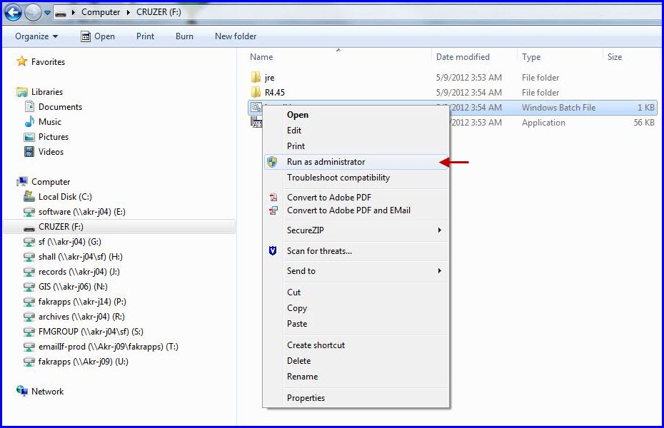
Microsoft Windows may prompt you for an administrator userid and password. If so, enter them. Your IT group can help if you don’t know an admin userid.
A black dos window will pop up and then the PTI Installer dialog box will pop up and request specific information as shown below.
- Install Directory and Data Directory. For most users the default locations are highly recommended. For users who have problems installing to these location (usually insufficient administrator privileges on their computer or other network constraints), the program can be installed elsewhere, but you will need to remember to change these settings if running the installer in the future. If you have been running the PTI, and are installing a new version, then it is very important to use the same install directory and data directory as the original installation.
- Type of Installation - Production is the selection you want to go with. The installer can also be used to create Training versions of the system by changing this selection.
- Archive old reports? – This setting tells the software program to archive all old reports collected for the year in a separate location.
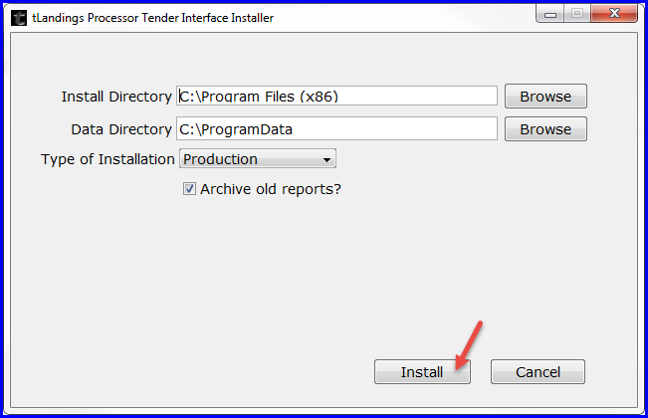
You can install both the PRODUCTION PTI application and the TRAINING PTI from this link. Note the Type of Installation – it defaults to Production but can be changed to Training from the down arrow.
- Click on the Install button.
- The installer will show progress with the green progress bar, in fits and starts. Please be patient if the progress bar seems to not be moving, but the installer is actually working.

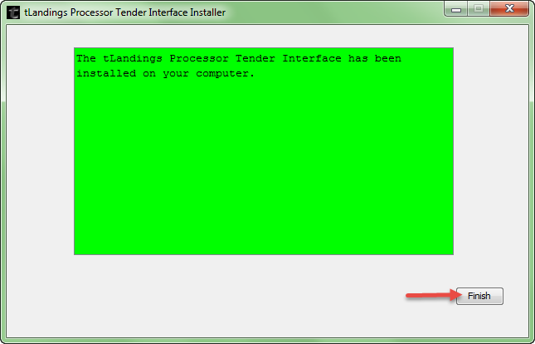
- If you see a green screen like the one above that means you successfully installed the software. Click on Finish to complete the process.
- A PTI Icon should have been created on your desktop, this is your shortcut to opening the seaLandings program.

Step 5.
- Note: If you or your IT Group logged in as an Administrator user to do the install, but you normally login as a non-admin user, then it is important to log out and login as your normal non-admin userid.
- Double click on the PTI desktop icon as shown below and login into PTI.
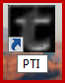
The Login dialog box will show the release and build numbers for the installed software. They should match the release and build number for the installer you downloaded. Once you confirm that the release and build numbers are correct you can enter your userid and password, and login into PTI.

If you are uncertain of the version of the PTI currently on your machine, just open the PTI and above the login you will see the release and build numbers, which identify the version you have installed.

